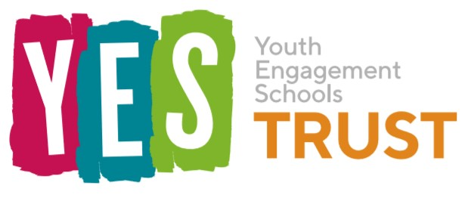

The Youth Engagement Schools (YES) Trust would like to open The Keystone Academy in September 2022. The school will accommodate students with Education & Health Care Plans in the 4 to 16 age range, whose primary needs are related to Social, Emotional & Mental Health. Given the typical challenges and difficulties these young people face, and in response to the Shropshire Local Authority specification, we aim to achieve better outcomes for our cohort than local schools are in a position to offer. We aim to improve each learner’s life chances and allow them to thrive in modern society.
The YES Trust is keen to hold a consultation set out by Section 10 of the Academies Act 2010. We are consulting on our plans to provide further information to the Secretary of State in support of our application to enter into a Funding Agreement that will enable the Academy to open.
Our consultation period will run from Monday 11th October 2021 to Monday 29th November 2021. During this time we will be inviting all stakeholders, prospective parents/carers and students as well as the members of the local community to share their opinions on the plans for The Keystone Academy. With this in mind, we would be grateful if you could complete the below questionnaire.

QUESTIONNAIRE

- Which group do you represent? (Please circle your answers.)
- Parent/carer
- Member of the local community
- Professional working with children

If you are a professional working with children, please state which agency you represent:

……………………………………………………………………………………………………………

- Do you agree that the Secretary of State should enter into a Funding Agreement with Youth Engagement Schools Trust?

- Yes
- No

- Do you support the proposal to open a new school in Shrewsbury?
- Yes
- No
If No, please state your reasons why: ……………………………………………………………………………………………………………
……………………………………………………………………………………………………………
……………………………………………………………………………………………………………

- How do you feel about the new school’s vision and ethos?
……………………………………………………………………………………………………………
……………………………………………………………………………………………………………
……………………………………………………………………………………………………………

Please return this questionnaire to admin@thekeystoneacademy.org or post it to:
The YES Trust
Office 4B Riverside
Congleton
CW12 1DY

Thank you for taking the time to complete this questionnaire. Your feedback is very much appreciated.

