

**Useful information**

**For Students Living**

**At Mardol House**

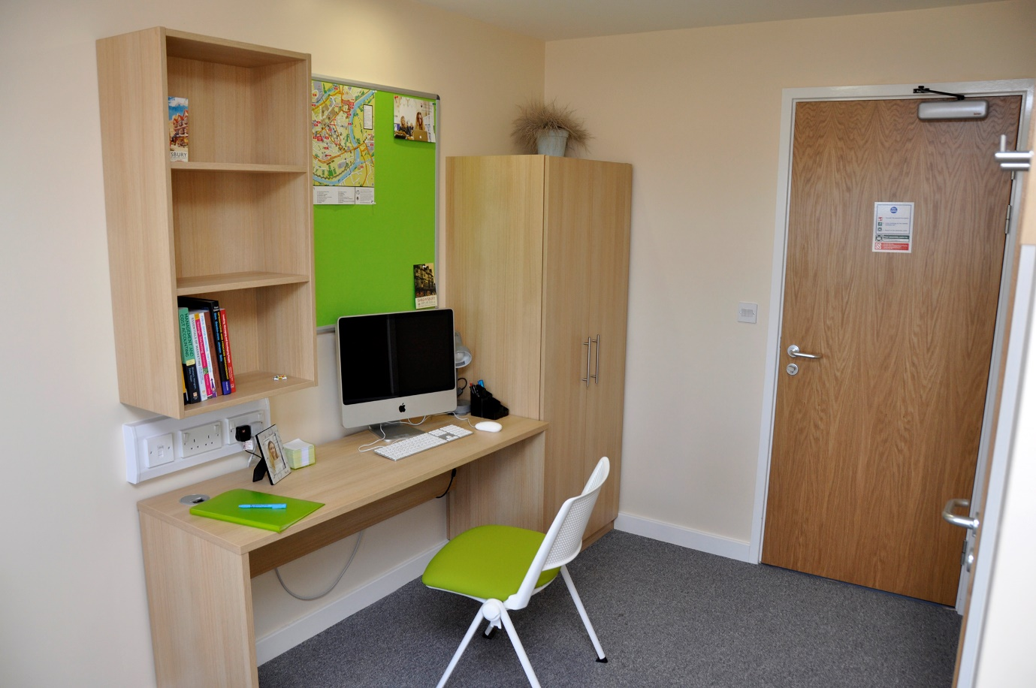

**Contents Page**

1. Introduction 3
2. First things first… 3
3. Concierge Contact Details 3
4. Premises and property matters 3
5. Reporting premises and property matters 3
6. Access to Student Accommodation/Inspections 4
7. Pastoral/Welfare matters 4
8. Letters/Mail & Parcels 4
9. Your Postal Address 4
10. Access control – Using your Key Fob 4
11. Window restrictors 5
12. Room transfers 5
13. Posters and Pictures 5
14. Lost Fobs and Keys 5
15. Cooking & Cleaning 5
16. Wi-Fi access 6
17. Laundry 6
18. Bicycles 6
19. Mardol House Smoking Policy 6
20. Security 6
21. Fire Procedures 7
22. Fire Doors 7
23. Smoke/Heat detectors/Fire Extinguishers 7
24. Routine Maintenance 7
25. Complaints Compliments and Escalation Arrangements 7
26. Accommodation disciplinary procedure & process 8
27. Heating and controls 9
28. Electrics 9
29. En-suite Facilities 9
30. Insurance 10
31. Overnight Guests 10

**1 Introduction**

Here at Mardol House, Shrewsbury, we have a great team ready to help and support you to make your time with us a success.

The team have pulled together some useful information to help you settle in quickly and are as comfortable and as safe as possible, please take the time to read and digest this information.

**2 First things first…**

Please complete your **room inventory** within 24 hours of arriving and return it to the Concierge. This forms part of your tenancy agreement and is an important check for both you and the team. This will be used again for future room checks and when you leave us to ensure our high standards are maintained. You may be charged for any discrepancies so it’s important that this is completed accurately.

**3 Concierge Contact Details**

Depending on the nature of your enquiry, you can contact the team in a variety of ways;

Email: concierge.helpdesk@shropshire.gov.uk

In person: on site at Mardol House

Mobile 07990 085610

Please note there are pockets around the building where the mobile signal is poor. If you are unable to contact the member of staff on duty please be patient as they move around the building.

There is a member of staff on duty 24 hours a day, however, the reception desk is not manned 24 hours per day, the Concierge Team have duties that have to be performed in and around the building that will mean they are away from the desk for periods of time.

**4 Premises and Property matters**

Shire Services are responsible for coordinating and running Mardol House and Tannery East Student Accommodation, they want to create a good environment for you to complete your studies so will be happy to help with any premises matters such as repairs and maintenance.

**5 Reporting premises and property matters**

Your key contacts are the Student Accommodation Concierges who are based at Mardol House reception.

Report any issues you may have in relation to the accommodation to the Concierge team.

The Concierge team will e mail you to confirm that the matter has been reported and will e mail you again to update on the action taken once a contractor has attended to the matter.

**6** **Access to Student Accommodation/Inspections**

The concierge team will not enter student accommodation unless accompanied and performing a specific duty.

Or in the event of an emergency repair that requires immediate attention such as a burst pipe or a leak.

A termly inspection will be carried out however you will be notified of this beforehand and the concierge will be accompanied by a colleague. Students will be notified of any issues that need to be addressed following inspection.

**7 Pastoral/Welfare matters**

Mardol House has an Assistant Residential Tutor who lives on site and is available to offer you pastoral support and care. Your Assistant Residential Tutor will introduce themselves to you within the first few days so that you know who they are, how they can support you and where to find them. If you have not been introduced within your first week please speak to the Concierge who will be able to arrange an introduction for you.

**8 Letters/Mail & Parcels**

We all like to receive mail and letters from home so the team are keen that post and parcels are stored securely, because of this you are asked to collect post from Mardol House reception. The Concierge will email you to let you know that there is a parcel / post to collect. Your student ID or other photographic ID will be required to collect your package.

**9 Your Postal Address**

Please note that the Concierge can only accept post and parcels for residents. Equally if it is unclear from the address details who the recipient is the item may be returned to sender.

To avoid any confusion, we recommend using the following postal address;

Your Name

Room number

University Centre Shrewsbury,

Mardol House,

Claremont Street,  
Shrewsbury   
SY1 1QL

**10 Access Control – Using your fob**

For your safety and security Mardol House operates a combination of fob and key entry system. Your fob is individually programmed to allow you access to communal facilities and your floor. Your key will operate your individual room / apartment.

To use your fob

* Hold the fob in front of the reader (small box approx. mid height near door)
* The door will unlock for a short time

**11 Window Restrictors**

For safety reasons, please do not tamper with the safety restrictors on the windows in your accommodation. If restrictors have been altered or tampered with you will be charged.

**12 Room Transfers**

If you wish to move, we will do our best to transfer you to an alternative room. You can apply to change your accommodation; however, it is often best to settle in for a few weeks before requesting a move. If you wish to be considered for a move, please speak to the Concierge in the first instance. Please also note that an administration cost will be charged if you decide to move.

**13 Posters and Pictures**

In all areas of student accommodation, posters, pictures and decorations may only be fixed on noticeboards provided by using drawing pins, or on doors by the use of white-tack. Please note that notices, posters and/or decorations must not be fixed on walls, ceilings, windows or in corridors, as this can cause damage. Under your License Agreement, you will be charged for any damage caused, including damage from blue-tack, and drawing pin marks.

**14 Lost Key Fobs and Keys**

If you lose or misplace your key fob or key please report this to the Concierge as soon as you can. If you are locked out of your room, the Concierge will verify your identity and help you to access your room. There will be a charge for replacing lost keys and fobs.

**15 Cooking & Cleaning**

All residents have a responsibility to keep their own rooms clean, tidy and well maintained as well as take a share in maintaining standards by cleaning up after themselves and leaving all communal areas in a clean condition so that everybody can use clean, safe facilities.

**You are responsible for:**

* Washing your dishes
* Leave the facilities as you would expect to find them
* If you spill something, wipe it up
* Clean the top of the hobs when you have finished
* Do not leave spillages on the hobs to burn
* Do not leave cooking unattended
* After cooking please remember to turn off hobs and ovens
* If you burn food, it may set off the fire alarm
* Keeping the fridge clean, keep the internal drainage free of debris and discard any out of date food.
* Emptying bins in the communal kitchens. Any rubbish bags should be securely tied before being moved and placed in the Bin Store on Level 1.

A dust pan and brush will be provided in each kitchen, a mop and bucket and vacuum is available on request, please see the concierge.

The Assistant Resident Tutor, accompanied by a member of the concierge team will inspect the communal kitchens and bedrooms once per month, these visits will be at a set time, notified to students in advance.

**16 WIFI Access**

WIFI connection is offered within Mardol House. Simply log in using your usual University username and password.

**17 Laundry**

There are laundry facilities on site comprising washing machines and tumble dryers. There is a fee for using the laundry. Details of how to use these facilities and what the current charges are for this facility is displayed in the laundrette. The facility is found on the 3rd floor.

**18 Bicycles**

There is a bike rack sited opposite to the Reception at Mardol House which residents are free to use. Please note that items are stored here at your own risk.

Bikes must not be brought into the accommodation.

**19 Mardol House Smoking Policy**

In the interests of safety and public health, smoking of cigarettes includingelectronic cigarettes is not permitted within Mardol House (including common areas). All bedrooms are fitted with smoke detectors. Fines may be issued to those who ignore the above rule.

Smoking should only take place in the area outside of the building away from the door to reception. Smokers are asked to be considerate of other people in the vicinity when they are smoking and to dispose of used cigarettes carefully, both to avoid litter and risk of fire.

**20 Security**

We provide a secure environment and ask for your help to maintain our high standards by following this security guidance;

* Bedroom and corridor doors must always be closed; wedging open a fire door is not only a fire risk, but a security risk
* Do not leave valuable or personal items in communal areas
* Do not allow strangers in through doors. If you are in doubt close the gate or door behind you and inform the Concierge
* Ensure all visitors sign in and out
* Concierge have the right to refuse entry to non-residents
* Be mindful of taking photographs of fellow students and staff within the building check they are in agreement
* Please note that the roof of Mardol House is out of bounds to students

**21 Fire Procedures**

Mardol House has been refurbished to a very high standard and offers residents a high degree of protection in the event of a fire.

***In the event of a fire***

If the fire alarms are sounding you must evacuate by the nearest fire escape. Fire action notices are posted in all bedrooms and corridors highlighting what to do in a fire and where the nearest fire evacuation points are. Please take time to familiarise yourself with these details. To maintain safety standards from time to time the Concierge may run fire evacuation drills to ensure that students, residents and colleagues are all aware of procedures.

The fire alarm will be tested between 2.45pm and 3.00pm every Tuesday, the alarm will sound briefly twice. If the alarm sounds for an extended period of time on a Tuesday afternoon, please evacuate in the usual manner.

**22 Fire Doors**

For safety fire doors are designed to self-close, please do not prop them open or adjust any of the fixtures or mechanisms as this could put yourself and others at risk.

**23 Smoke/Heat Detectors/Fire Extinguishers**

Please do not cover or tamper with the smoke and heat detectors on the ceilings. This will make them ineffective and unable to protect you and others.

Please do not remove tags from the fire extinguishers.

**24 Routine Maintenance**

There are occasions when Routine Maintenance needs to be carried out within student accommodation by the Concierge team or Contractors, such as emergency lighting checks. You will be notified in advance when these are due to take place.

Daily building checks will be undertaken by the Concierge team usually mid-morning to identify any defects or maintenance requirements within the communal areas.

**25 Complaints, Compliments and Escalation Arrangements**

The concierge team is the first point of contact. If you have already been in touch with them and remain unhappy or wish to share praise, please escalate the matter to the managers shown below.

If you have any issues with the accommodation at Mardol House that you do not feel are being dealt with in a timely or appropriate manner by the Concierge Team, please contact the following members of the Facilities Team who are available to discuss and resolve your concerns.

Jacky Hammett Area Manager

Telephone 01743 250273 E mail [jacky.hammett@shropshire.gov.uk](mailto:jacky.hammett@shropshire.gov.uk)

Janet Croft Service Manager

Telephone 01743 250258 E mail [janet.croft@shropshire.gov.uk](mailto:janet.croft@shropshire.gov.uk)

**26** **Accommodation disciplinary procedure & process**

Students are asked to consider the wellbeing of others and behave appropriately in Mardol House. The facilities team have an obligation to address issues of antisocial behaviour and health and safety infringements, these matters will be raised with the ART to address with the students concerned.

Students are expected to be in appropriate dress when in reception and other public areas of the building.

Your Accommodation Handbook, Accommodation Policies and Tenancy Agreement highlight full details of the behaviours that are expected and how unacceptable behaviours are addressed, below is an example of behaviours that are unacceptable.

To help create a safe, happy and healthy environment to live, study and relax, students are asked to consider others when they are in the building.

Issues which the Concierge team will report to the Facilities Support Team include: -

• Smoking including vaping

• Making excess noise

• Damaging property

• Creating Health and Safety infringements

• Causing false or malicious fire alarm activations

• Antisocial behaviour

• Your guests causing problems in accommodation

• Security breaches

• Leaving facilities in unclean, unsafe condition

• Intimidation and bullying

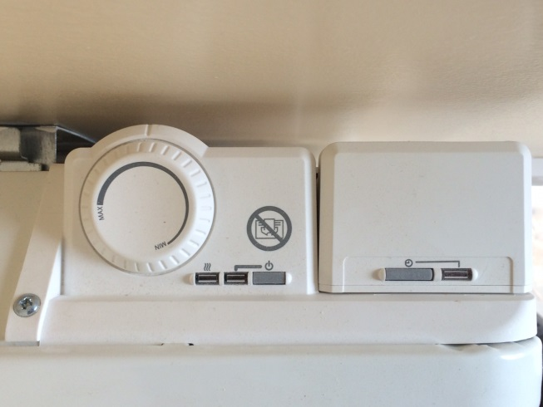**27 Heating and Controls**

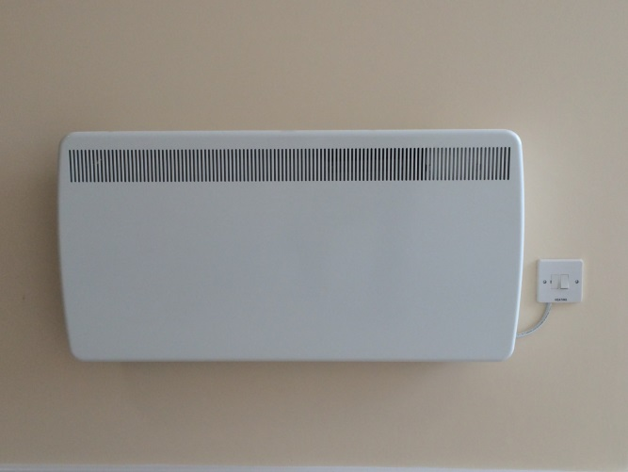The electric wall heater is operated by pressing the on/off button followed by the boost button. The controls have been set to approximately 25 degrees; there will be no greater heat output from the heaters even though the dial still moves. If your room is particularly cold, there is a Boost button, which will provide full heater output for a two-hour period.

Do not cover the heater, this is a fire risk and steam produced from wet clothes can falsely activate the fire alarm. It can also cause the heater to break as the heating elements can over heat.

If the controls on the heater are not adjusted during a 24 hour period the heater will revert to a frost setting of 5 degrees.

Please ensure that the power is turned off before cleaning the heater; the outside can be cleaned by wiping it over with a soft damp cloth there is no need to use abrasive cleaning powders or furniture polish.

**28 Electrics**

The plug sockets have been labelled for specific use. Please do not plug other appliances into these, as you may ‘trip’ the electrics which will cause a break in the electric supply. If the circuit has tripped, the Consumer Unit which is behind your bedroom door will activate and the trigger switch or breaker will be in the ‘off’ position. Ensure you remove the offending plug before switching the circuit to the ‘on’ position, to restore power. If in any doubt, please speak to your Concierge.

Students must not tamper with any of the electrical fixtures or fittings, please report any issues to the concierge.

**29 En-suite Facilities**

Please check the drain in the shower regularly and remove any blockage. Ensure water is able to drain freely. Do not leave taps and showers running unnecessarily as this can cause leaks and flood the bathroom.

The heated towel rail in the bathroom is controlled using the on/off switch.

**30 Insurance**

A basic insurance is provided, however you will need to arrange cover for expensive items and may want to extend the cover to provide additional cover.

**31 Overnight Guests**

Any visitors to the accommodation who are staying overnight should be made known to the Concierge on duty and sign in. Whilst overnight guests are permitted, they should not be staying overnight on a regular basis. There is a policy of 2 nights per week and you are reminded that you are responsible for your guest and their behaviour. Guests should not be making use of the kitchen facilities and should not be left unsupervised. Students are also asked to be mindful of other students particularly in shared cluster rooms where you will be held responsible for any actions taken by your guest.

**We hope you find this information useful but if you have any questions please contact the Concierge who will be happy to help.**

All policies and procedures relating to the student accommodation at Mardol House   
are available to view in full on the website.

[**www.shropshire.gov.uk/mardol-house-student-accommodation/**](http://www.shropshire.gov.uk/mardol-house-student-accommodation/)

**Version 7.0**

**Reviewed August 2023**

**Next Review Date August 2024**