Property Services Group
Approved List of Contractors
Application Form

CATEGORY 13 – TARPAVING

Name of Applicant:  (please insert) | ……………………………………………………………………………..

Please read the Conditions and Operation Guide Document carefully before completing this document.

This document consists of 25 pages and must be completed in its entirety.

All requests for supporting documents must be included. Failure to do so
will exclude your application from being processed

Shropshire Council
Approved List of Contractors Application

Contract Description:

This is an Approved List of Contractors for the provision of Tarpaving Services.

Contents

Section | Description | Page
A | Area and value band selection matrix | 3
A | Map of Shropshire identifying areas 1 - 5 | 4
B | Applicant Organisation Details | 5
C | Financial & Insurance Information | 7
D | Claims & Contract Terminations/Deductions | 9
E | Health & Safety and Equal Opportunities | 10
F | Contract Specific Questions | 16
G | Industrial Standard Qualifications | 21
H | Pricing Schedule | 22
I | Declaration | 24
J | Checklist | 25

Section A

Selection Matrix – CATEGORY 1 – TARPAVING

MUST BE COMPLETED BY ALL APPLICANTS

Please select the Area(s), Value Bands and Hours that you are applying for
by ticking () the relevant boxes
(Please note you must tick each box you wish to be included for)

 |  | Category 13
 |  | Tarpaving
Areas* | 1
 | 2
 | 3
 | 4
 | 5
Value Bands | £0 - 2k
 | £2k - 50k
 | £50k - 170k
Hours/Work | Reactive Day Work:  Normal Hours  8am – 4.30pm  Monday – Friday
Emergency Reactive Day Work
Normal day Hours
8am – 4.30pm
(within 2 working hours)
Monday – Friday

Emergency
Out of Hours
4.30pm – 8am and weekends
 | Quotations and Tenders only and not Reactive/Emergency Day Work

*Please see enclosed Shropshire Area Map on the next page.
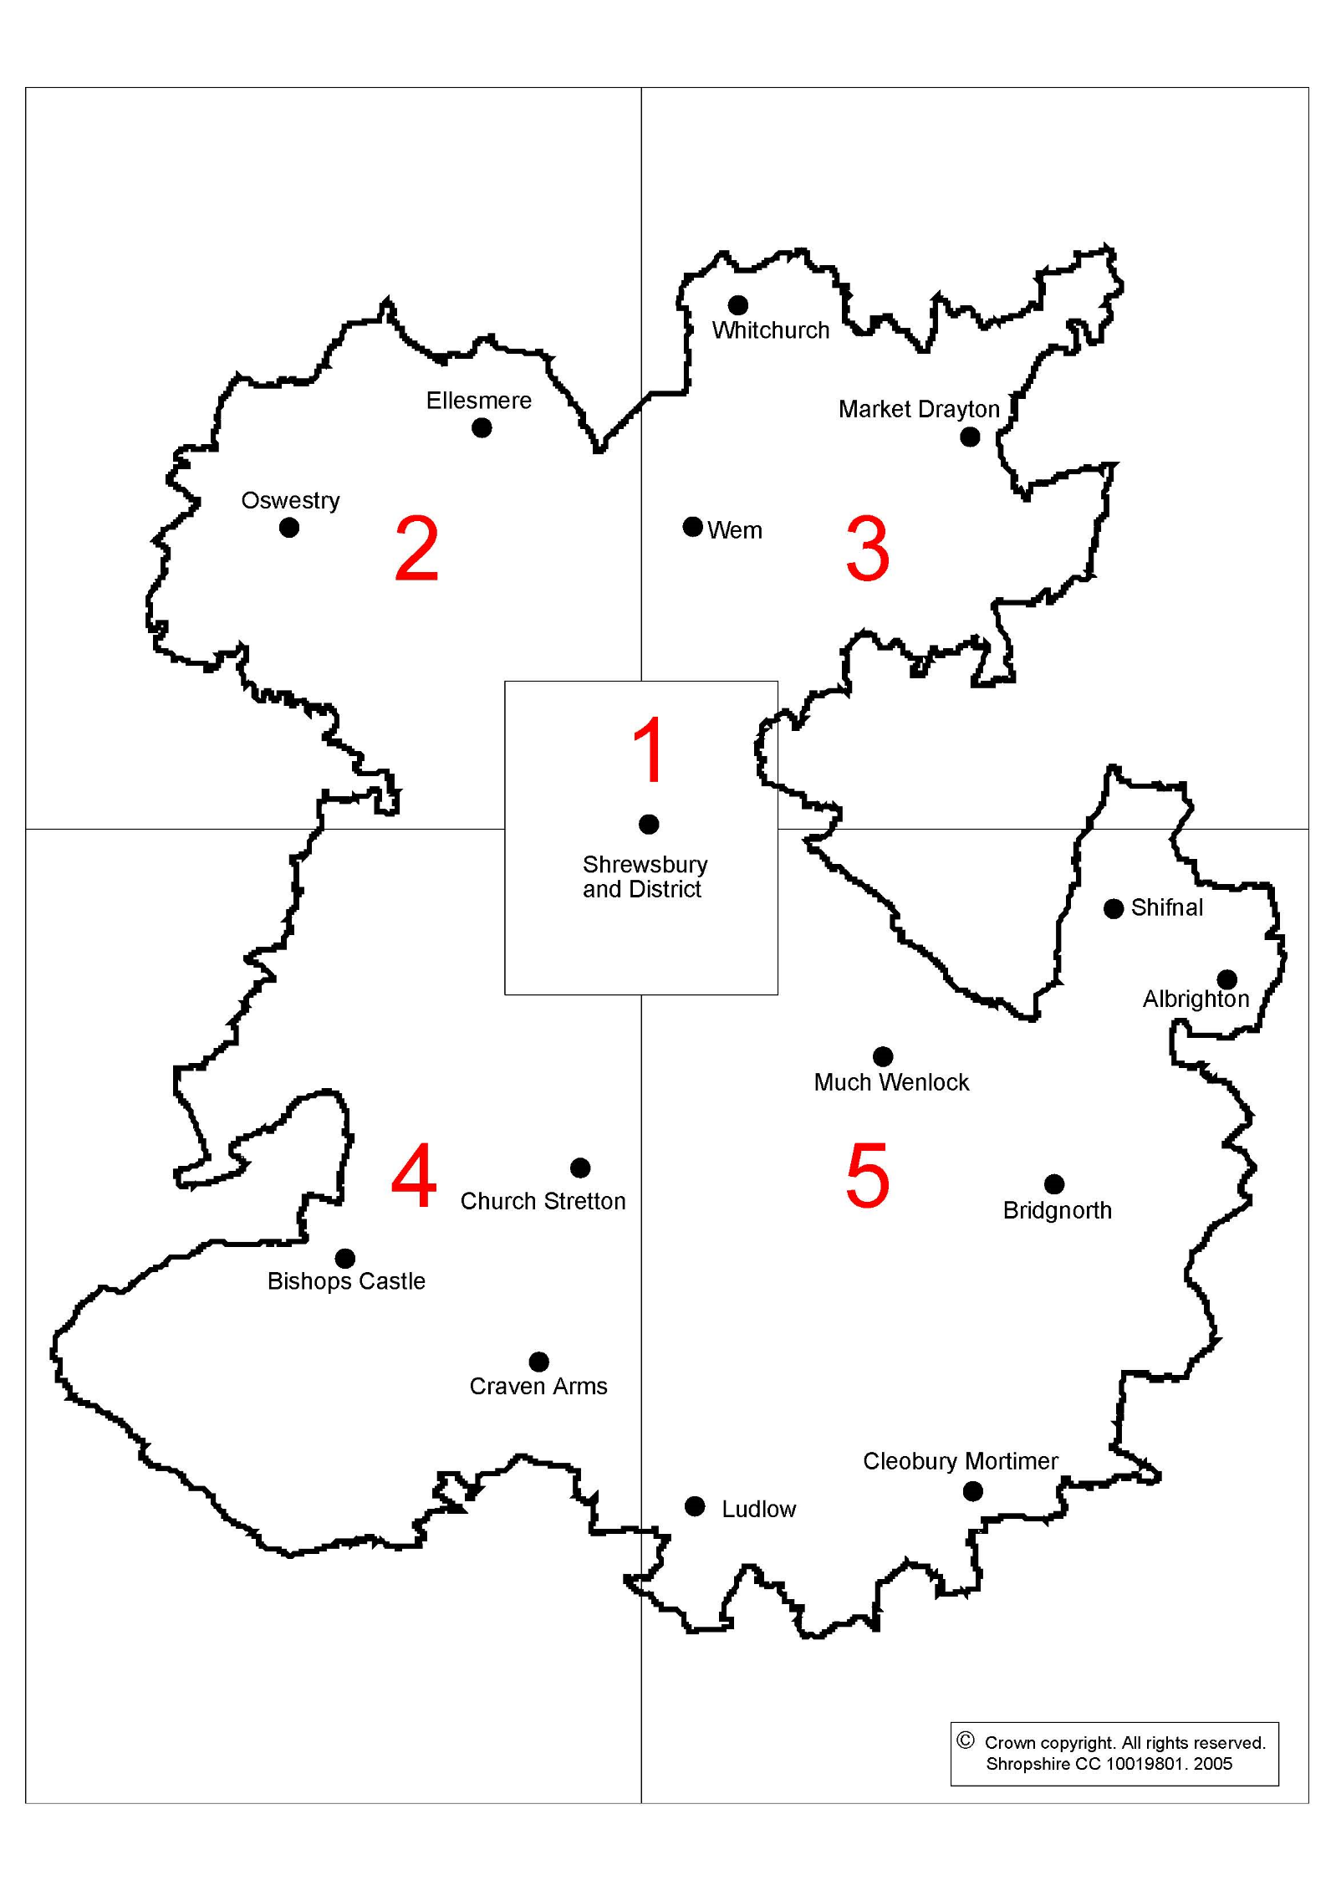

Section B

Applicant Organisation Details

MUST BE COMPLETED BY ALL APPLICANTS

1. | Applicant Details
1.1 | Name of Company/Organisation:  Address:  Postcode:  Tel:  Mobile:  Company Email:  (Orders Only) Email:  {Please ensure an e-mail address is stated for electronic orders}
1.2 | Registered name (if different from above):  Registered Office Address:  Postcode:  Company registration number:
1.3 | Details of the individual completing this application and to which we may correspond:  Name:  Job title:  Correspondence Address:  Postcode:  Tel:  Mobile:  Email:
1.4 | Please state the type of your Organisation (Sole Trader, Partnership, Private Limited Company, Public Limited Company or other):
1.5 | Are you a Small or Medium Sized Enterprise (SME)  *An SME can be defined as an enterprise which employs fewer than 250 people  If No, Please confirm you are an enterprise which employs more than 250 people |  | YES/NO  YES/NO
2. | Company History/Background
2.1 | Date Company established:
2.2 | Is the applicant a subsidiary of another company as defined by the Companies Act 1985? |  | YES/NO
2.3 | If YES to 2.2 give the following details of the Holding/Parent Company:  Registered Name:  Registered Address:  Postcode:  Registration Number:
2.4 | Have any of the Directors, Partners or Associates been involved in any firm which has been liquidated or gone in to receivership? If so please give brief details. |  | YES/NO
2.5 | Have any of the Directors, Partners or Associates has a relative(s) who are employed by the Council or as a Councillor? |  | YES/NO

Section C

Financial & Insurance Information

MUST BE COMPLETED BY ALL APPLICANTS

1. | Insurance Details
* | Why do we need to know this?  We need to ensure that all of our suppliers have adequate insurance. The Council has set minimum insurance requirements which all companies working with the Council must adhere to.  Please note that on some limited occasions the council may agree to vary these levels dependant on the nature of the contract.
1.1  (a) | Please Confirm that you hold a minimum of £5,000,000 Public Liability Insurance and Employer’s Liability Insurance  Please enclose photocopies of your Certificates of Insurance duly signed as authentic copies of the originals. Enclosed  Mandatory Requirement | YES/NO  YES/NO
1.1  (b) | Please detail the relevant policy information and state if any conditions or exceptions apply to the policy.  Name of Insurance Company ……………………………………………...………………………  Date policy taken out ……………………………............................……………………  Expiry date of the policy ………………………………………………………………………  Policy number/reference ………………………………………………………………………  Conditions/Exceptions ………………………………………………………………………  ………….………………………………………………………………………………………….………….
2. | Financial Details
* | Why do we need to know this?  Financial details are required in order to check that your company has sufficient financial resources to undertake the contract. This information will also ensure that your company is in a stable position and is likely to fulfil the contract for the period required. Shropshire Council may request further information.
2.1 | Please provide a brief summary of your annual turnover and profit in the last 3 years.  For information only.  (Please insert figures only – we will contact you if we require a copy of your accounts)  Company  Year Last three financial years Turnover £………………………. £………………………. £………………………. Profit(Loss) £………………………. £………………………. £……………………….  (If exact figures are not available please provide your best estimate of the figures required)
2.2 | Please show below your company’s turnover in the last three financial years, relating Tarpaving Services, if not already stated above.  For information only  (Please insert figures)  Year Turnover  Last three financial years £………………..……….…………….…………. £…………………………………….……………. £………………………………..…..…………….  (If exact figures are not available please provide your best estimate of the figures required)

Section D

Claims & Contract Terminations/Deductions

MUST BE COMPLETED BY ALL APPLICANTS

* | Why do we need to know this?  The Council needs to ensure that organisations have a proven record of completing contracts in full and to a high standard, and do not have any outstanding claims against them.
1. | Outstanding Claims / County Court Judgements
1.1 | Do you have any outstanding claims, litigations or judgements against your organisation? | YES/NO
1.2 | If YES to 1.1 please provide further details.
2. | Contract Terminations/Deductions
2.1 | Please give details of all contracts in the last 3 years which have been terminated early giving the name of the client company/authority, the date of termination and the reasons for termination.
2.2 | Please give details of all fines, penalties or deductions incurred in the last 3 years as a result of non-performance under any contract.

Section E

Health & Safety and Equal Opportunities

MUST BE COMPLETED BY ALL APPLICANTS

1. | Health & Safety at Work
* | Why do we need to know this?  We need to ensure that all companies that work with Shropshire Council are able to operate safely. We assess this by asking questions about arrangements at the contract stage and continue to monitor ongoing performance with all companies working on our behalf.  Health & safety measures do not have to be expensive, time consuming or complicated – especially for smaller companies. In fact, safer and more efficient working practices can save money and greatly improve working conditions for employees. Shropshire Council is committed to promoting safe and proportionate working practices to companies as it recognises the benefits this can bring for companies competing for business both for local authority contracts and elsewhere.  Information to help small companies is available on the Health and Safety Executive’s (HSE) website.  Health and Safety Executive’s website: http://www.hse.gov.uk/  Looking after your Business: http://www.hse.gov.uk/business/
1.1 | Does your organisation have a formal health and safety policy or statement?  *(if you employ 5 or more employees you are required to produce a Health and Safety Policy/Statement under the Health & Safety at Work Act 1974)  Please tick here if copy enclosed  Mandatory Requirement (if you employ more than 5 employees) |  | YES/NO
1.2 | Does your organisation currently hold any SSIP (Safety Schemes in Procurement) certificate with the SSIP logo on it, i.e. CHAS Accreditation, SMAS, EXOR, Safecontractor, Safe-T-Cert, Acclaim Accreditation Certificate as these are required as part of the Health and Safety requirements by Shropshire Council  Please tick here if copy enclosed  Mandatory Requirement |  | YES/NO
1.3 | Do you provide yearly Asbestos Awareness Training to your employees, appropriate to their role within the Company, which is in accordance with United Kingdom Asbestos Training Association (UKATA) Category A requirements? If so, please provide evidence.  Mandatory Requirement  Please tick here if enclosed |  | YES/NO
1.4 | Has your company been served with an enforcement notice or been prosecuted in the past 3 years for breaches of health and safety legislation? |  | YES/NO
1.5 | If YES to 1.4 please give details of the prosecution or notice (and what measures you have taken to ensure the issue(s) will not re-occur).
1.6 | Do you routinely carry out Risk Assessments? |  | YES/NO
1.7 | If YES to 1.6 please state what has been assessed.  (At certain times, the Council may request copies of risk assessments, safe working procedure, or safety method statements.)
1.8 | Do you have a health and safety training programme for employees? |  | YES/NO
1.9 | If YES to 1.8 please state what training has been given.
1.10 | Does your company monitor:  - Accidents  - Ill health caused by work  - Health & Safety Performance |  | YES/NO  YES/NO  YES/NO
1.11 | Does your company have a recognised health & safety management system?  Please give details below: |  | YES/NO
1.12 | Please state how many accidents have been reported to your Enforcing Authority under RIDDOR (The Reporting of Injuries, Diseases and Dangerous Occurrences Regulations) in the last 2 years.  Total  No. of accidents reported under RIDDOR last year  No. of accidents reported under RIDDOR this year
1.13 | Does your company consult with employees on health and safety?  If YES, please give details below. |  | YES/NO
1.14 | Will you be using any subcontractors as part of this contract? (including Emergency and Day works) |  | YES/NO
1.15 | If YES to 1.14 please give details of who your subcontractors are.  Failure to notify Shropshire Council’s contract administrator of this will lead to suspension from the approved list
1.16 | If YES to 1.14 how do you ensure they are competent?
1.17 | Where do you get your competent health and safety advice?  To meet your legal responsibilities in ‘The Management of Health and Safety at Work Regulations 1999’ you must appoint one or more competent people to help you comply with your duties under health and safety law so you can prevent accidents and ill health at work. In practice, you can be that competent person as long as you know enough about what you have to do. If the risks are complex and you do not have access to competent advice in-house, you may want to appoint a safety consultant to help you.
1.18 | Do you provide yearly Asbestos Awareness Training to your employees, appropriate to their role within the Company, which is in accordance with United Kingdom Asbestos Training Association (UKATA) Category A requirements? If so, please provide evidence.  YES/NO  Please tick here if enclosed
2. | Equal Opportunities
* | Why do we need to know this?  The equality duties placed on public authorities requires the Council to have due regard to the need to eliminate unlawful discrimination.  We need to ensure all companies that work with Shropshire Council comply with both UK and EU regulations regarding equal opportunities and discrimination law. The Council actively promotes equal opportunities in procurement and partnership.  The Council also needs to ensure that there are no outstanding claims against your organisation regarding discrimination.  Information to help small companies is available at:  Equality and Human Rights Commission -  http://www.equalityhumanrights.com/advice-and-guidance/here-for-business/
2.1 | Do you have an Equal Opportunities Policy or statement which complies with your statutory obligation under UK/EU equalities and discrimination legislation (or equivalent legislation and regulations in the countries in which you employ staff) and, accordingly, your practice not to treat one group of people less favourably than another.  UK/EU equalities and discrimination legislation includes:-  - Equality Act 2010  - Employment Equality (Religion or Belief) Regulations 2006  - Employment Equality (Sexual Orientation) Regulations 2003  - Human Rights Act 2004  Please tick here if enclosed |  | YES/NO
2.2 | As a contractor providing a public service on behalf of a local authority, you have a duty to comply with the General Duties of the Equality Act 2010 as outlined below.  - Eliminate unlawful discrimination, harassment and victimisation,  - Advance equality of opportunity between different groups; and  - Foster good relations between different groups  How do you promote equality, towards both users and employees as part of your operations?
2.3 | In the last 3 years, has any claim or finding of unlawful discrimination been made against your organisation by any court? |  | YES/NO
2.4 | If YES to 2.3, please give details.
2.5 | In the last 3 years, has your organisation been the subject of formal investigation by the Equality and Human Rights Commission (or Commission for Racial Equality, the Equality Opportunities Commission and/or the Disability Rights Commission prior to October 2007) on grounds of alleged unlawful discrimination? |  | YES/NO
2.6 | If YES to 2.5, please give details.
2.7 | (NB Organisations with less than 5 employees are not required to respond to questions 2.7, 2.8 and 2.9)  Is your policy on equality and diversity set out?  - In instructions to those concerned with recruitment, training and promotion?  - In documents available to employees, recognised trade unions or other representative groups or employees  - In recruitment advertisements or other literature?  Please supply relevant examples of the instructions, documents, recruitment advertisements or other literature.  Please tick here if enclosed |  | YES/NO  YES/NO  YES/NO
2.8 | Do you endeavour to both eliminate discrimination amongst your workforce, and also promote the diversity of your workforce e.g. do you take steps to encourage people from under-represented groups to apply for jobs or take up training opportunities?  YES / NO  Please provide details:
2.9 | Is it your policy as part of your grievance process to include in that grievance process all complaints relating to race or ethnic origin, disability, gender, sexual orientation, religion, belief or age. Furthermore, do you include in your grievance process any complaints related to being victimised or harassed as a consequence of bringing a grievance?  YES / NO  Please provide details:
2.10 | Organisation with less than 5 employees must confirm below that they will meet the requirements set out in questions 2.7, 2.8 and 2.9 if they increase their number of staff above 5.  Confirmed |  | YES/NO
2.11 |  | Have all of your employees at your Company (that visit sites) been through the Enhanced DBS (Disclosure and Barring Service) checking process including child and/or adult barred list check  All Y E S / N O  If yes, please enclose details of employee names, DBS number and date of certificate on Appendix A of the DBS Agreement  Copy Enclosed Y E S / N O  Mandatory Requirement
Section F

Contract Specific Questions

MUST BE COMPLETED BY ALL APPLICANTS

1. | Experience & Resources
1.1 | How many years has your company been providing Tarpaving Services?  For Information Only ……...………….……. years
1.2 | Total number of employees: _________________  For Information Only
1.3 | Total number of employees engaged solely in the provision of Tarpaving Services?  For Information Only _________________
1.4 | Breakdown of employee position within company:  For Information Only  No. of employees  Overall Management …………………..  On site Management …………………..  Operatives …………………..  Financial/Commercial …………………..  Health & Safety / CDM …………………..  Admin/Clerical …………………..  Trainees/Apprentices …………………..  Other …………………..  Total Members of staff …………………..

2. | Please state any formal Quality and Environmental Assurance systems relevant to this contract, which your company operates i.e. ISO 9001:2008 and ISO 14001:2004 or EU Equivalent. Also any in-house policies or systems you may have in use.
 | Name of Awarding Organisation/Body | Registration Number | Name of Quality Assurance System | Date Achieved | Date of Expiry/ Renewal
 | Please provide copies of the certificates you have given above or other proof of the qualifications. Enclosed |  |  |  |  | YES/NO

3. | Contract Experience and References – if you do not provide full contact details this will delay your application form.
3.1 | Please list below up to a maximum of 10 similar contracts undertaken by your company in the past 3 years or currently being handled.  Any previous Public Sector experience will be of particular interest. Those provided below may be selected for site visits.
 | Name of Client & Project Title | Client address & E-mail address | Value of Contract (£) | Nature of work undertaken | Contract Dates (From – To)
1
2
3
4
5
6
7
8
9
10

4. | Emergency Call-Out – only for Reactive Day Work
4.1 | Companies interested in being considered for Reactive Day Work repairs must confirm below if they can provide an 24 hour 365 days a year emergency repair service with a maximum response time of 24 hours or maximum response time to attend a site within 2 hours.  FAILURE TO COMPLY WITH THIS WILL RESULT IN NEGATIVE RAG RATING  (see Condition & Operations Guide Section I)  Please confirm that you agree to provide emergency cover  ‘in working hours’ (Monday – Friday 8am – 4.30pm) Y E S / N O  Please confirm that you agree to provide this cover ‘out of hours’ Y E S / N O  (Any other time out of working hours – 365 days)  If yes, please state below how this cover will be resourced and organised:  ………………………………………………………………………………………………………  ………………………………………………………………………………………………………  ………………………………………………………………………………………………………
Out of Hours Contact Telephone Numbers

Include names, telephone numbers (mobile and fixed) of all individuals to be used.

……………………………………………………………………………………………………..

……………………………………………………………………………………………………..

……………………………………………………………………………………………………..

……………………………………………………………………………………………………..

4.2 | Please provide details of other Organisations that you provide Emergency Call-Out cover for:-  ……………………………………………………………………………………………………..  ……………………………………………………………………………………………………..  ……………………………………………………………………………………………………..
5. | Type of Buildings
5.1 | Please confirm the type of buildings you wish to be considered for:  Gypsy Sites  Y E S / N O  Agricultural Premises  Y E S / NO  Commercial Buildings  Y E S / NO  Corporate Buildings  Y E S / NO  Domestic Housing  Y E S / NO  Historic/Listed Buildings  Y E S / NO  Schools  Y E S / N O  Small Holdings  Y E S / N O  ALL  Y E S / NO

Section G

Industry Standard Qualifications

Category 13 – Tarpaving

1.0 Additional Information

1.1 Please provide any additional information, which has not been covered within this
document that you feel is relevant to this contract:

Pricing Schedule

Please indicate your hourly rates below, which should not include mileage. Mileage to be charged at 45p/mile.

All rates must be completed

Hourly rate during normal hours Monday to Friday 8am-4.30pm
On cost + profit...................% Total Cost |  |  | £
 | Hourly rate after normal hours Monday to Friday 4.30pm to 8am
 | On cost + profit...................% Total Cost |  | £
Hourly rate for Saturday working
On cost + profit...................% Total Cost |  |  | £
Hourly rate for Sunday working
On cost + profit...................% Total Cost |  |  | £
Hourly rate for Bank Holiday working
On cost + profit...................% Total Cost |  |  | £
Apprentice hourly rate |  |  | £
Mileage to be charged at 45p/mile

Percentage additions on net cost of material to cover profit handling, etc. |  |  | %
Percentage additions on net cost of Sub-Contractors to cover profit handling, etc. |  |  | %
Any special conditions applicable to overtime working
Signed..................................................... |  | Name......................................................  (please print)
Position ……........................................... |  | Date........................................................
Rates to be reviewed yearly on 1st April in line with RPI

The Contracting Authority reserves the right to exclude any contractor from emergency call outs and reactive day works if their pricing schedule is deemed not appropriate. Contractors will however still be invited to quote/tender.

The Contracting Authority reserves the right to remove any contractor from the approved list if they deviate from the pricing schedule.

Section I

Declaration

MUST BE COMPLETED BY ALL APPLICANTS

Shropshire Council

Approved List of Contractors for the provision of Tarpaving

We confirm that this, our application, represents an offer to Shropshire Council that if accepted in whole, or in part, will form part of an Approved List of Contractors for Tarpaving Services at the prices and terms agreed and subject to the Conditions and Operation Guide Document, a copy of which we have received.

We confirm that we have not canvassed or solicited any member, officer or employee of the Council in connection with the award of this application.

We, as acknowledged by the signature of our authorised representative, accept these instructions as creating a binding contract between our self and the Council. We hereby acknowledge that any departure from the Instructions to Tender may cause financial loss to the Council.

Signed ………………………………………. Name…………………………………………...

Date ……………………..…………………..

Designation …………………………………………………..………..…………………………..

Company…………………………………………………..……..…………………………………

Address …………………………………………………………………………………………….

……………………………………………………………………………………………………….

……………………………………….……….. Post Code ………………………………………

Tel No ……………………..……………….. Fax No ………………………………………….

Mobile ………………………………………

E-mail address ……………………………………………………………………………………..

Web address ……………………………………………………………………………………….

Section A:
2. Non-Canvassing Certificate

Section J

Checklist

MUST BE COMPLETED BY ALL APPLICANTS

Section / Question No. | Mandatory & Requested Documents Enclosed | Tick if enclosed
C 1.1 (a) | Certificates of Insurance Mandatory Requirement
E 1.1 | H&S Policy Mandatory Requirement if more than 5 employees
E 1.2 | SSIP Accreditation Certificate Mandatory Requirement
E 2.18 | DBS (CRB) checks Mandatory Requirement
I | Declaration Mandatory Requirement

Please return your completed application form and mandatory documentation by email to contractorslist@shropshire.gov.uk

All works to comply with the Tarpaving Specification dated May 2016.

Alternatively you can send a hard copy and CD of the above to:
PSG Manager, Shropshire Council, Shirehall, Abbey Foregate, Shrewsbury, SY2 6ND

The approved contractors list will remain open and reviewed annually.

