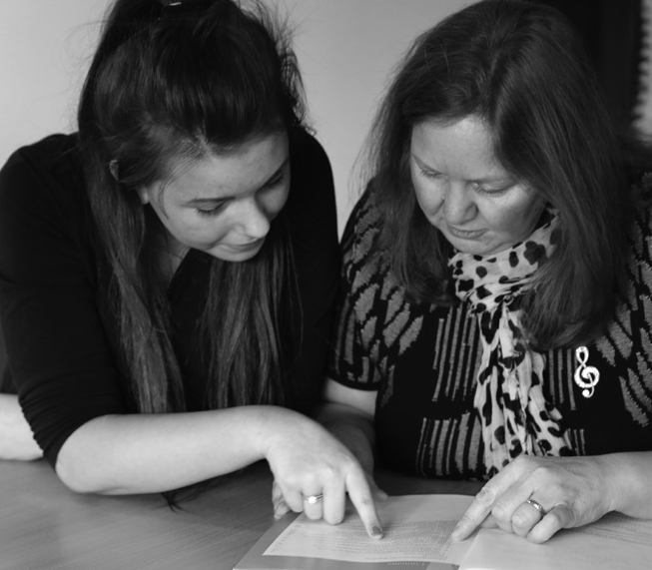
The critical reflection log

To be completed by the newly qualified social worker

Completing the critical reflection log

Responsibility for the completion of the critical reflection log rests with the newly qualified social worker. It should be shared with the assessor during supervision sessions and at the review points.

Completing all sections of this template electronically will assist internal and external moderation processes.

Guidance to help you complete this log is included within text boxes. The text will disappear when you start typing your answer. The text boxes will expand as you type in them.

Click here to download a supporting document, which includes all of the relevant guidance you will need to complete this template. You are advised to read this in full before starting.
The assessed and supported year in employment in Children’s Social Care

Critical reflection log part 1: beginning the ASYE

Part 1 should be completed by the NQSW in preparation for the support and assessment agreement meeting and presented to the assessor in advance of the meeting.

Consider your learning needs for the next three months and over the course of the year.
Consider key legislation relevant to Children’s Services generally and your employment setting specifically.
How do you plan to obtain the practice evidence you need?

Initial professional development plan 0 - three months

To address areas noted by assessor at the support and assessment agreement meeting (see section seven) as well as areas identified in this
document.

Period covered

Learning objective | How will you meet the objective? Development activity or action planned. | How does this link to the assessment outcomes for the ASYE? | What was the impact on your practice? | Date for completion and/ or review.

Critical reflection log part 2: reflection on learning in the first three months

The log, plus practice evidence, including service user feedback, undertaken and received in this period, to be submitted to the assessor in advance of the three month assessment review meeting

Taking into account all your learning to date, reflect on some of the challenges and ethical dilemmas you have encountered. Describe how you have developed new skills and knowledge and include an account of an intervention you are proud of , or which has aided your learning and development .
Suggested Word limit 1,750

Professional development plan three-six months

To address areas noted by assessor in the three month review as well as areas identified in this document.

Period covered

Learning objective | How will you meet the objective? Development activity or action planned. | How does this link to the assessment outcomes for the ASYE? | What was the impact on your practice? | Date for completion and/ or review.

Critical reflection log part 3: reflection on learning, three to six months

The log, plus practice evidence, including feedback from people in need of care and support, undertaken and received in this period, to be submitted to the assessor in advance of the six month assessment review meeting.

Taking into account all your learning to date, reflect critically on how you completed a Social Work Assessment or Risk Assessment. Describe what informed your decision making , and what social work methods and theories , or evidence based practice / research you used to come to a reasoned judgement.
(Suggested word limit 1,750 words)

Professional development plan six-twelve months

To address areas noted by assessor at the six month review as well as areas identified in this document.

Period covered

Learning objective | How will you meet the objective? Development activity or action planned. | How does this link to the assessment outcomes for the ASYE? | What was the impact on your practice? | Date for completion and/ or review.

Critical reflection log part 4: six to twelve months (the end of the ASYE)

The log plus practice evidence, including feedback from people in need of care and support, undertaken and received in this period, to be submitted to the assessor in advance of the final review meeting.

Critically reflect on how you have progressed in the management of risk over the ASYE. Discuss competing priorities of children, young people and parents balancing rights and risks. (Suggested word limit 1,500 words)
In what ways has your professional development over the course of the ASYE impacted on your professional skills, practice and the outcomes for children and young people in need of protection and or support? (Suggested word limit 1,000 words)
Looking forward how will you ensure your continuing professional development as a social worker?

Professional development plan end of ASYE/social worker

To address areas noted by assessor at the final review meeting as well as areas identified in this document.

Period covered

Learning objective | How will you meet the objective? Development activity or action planned. | How does this link to the assessment outcomes for the ASYE? | What was the impact on your practice? | Date for completion and/ or review.

Period covered

The assessed and supported year in employment in Children’s services

Direct observation template

Three direct observations to be completed by a registered social worker (at least two of these
to be completed by the assessor). These should be planned in advance to enable the NQSW to
evidence progressive development in their professional practice over the course of the ASYE.

Name of NQSW
Name and role of observer
Date and setting
of observation

Part 1: NQSW completes boxes on and two before observation

1. Brief background to observed contact between yourself and those in need of care and
support
2. Planning for intervention

NQSW completes box three after the observation.

3. Reflections on the observed practice

NQSW completes box four after reading the observer’s report.

4. Critical reflection and professional development
Bearing in mind the Knowledge and Skills Statement (Adults) 2015 capability level and
the Professional Capabilities Framework have you identified any specific areas for further
development? How do you intend to address these? What support do you need?

NQSW signature
Date

Part 2: Observer completes after the direct observation

5. Holistic assessment of the candidate’s capability demonstrated in the direct observation of practice (up to 500 words)

Observer completes after the direct observation

Action plan following the direct observation (if applicable)
Have areas of development/learning needs been identified that should be addressed in the NQSW’s PDP? What action needs to be taken to address these? Are there any other outstanding issues?
Feedback from people in need of care and support (if applicable)

Observer’s signature
Date

The assessed and supported year in employment in children’s services

Feedback from other professionals

This can be used by professional colleagues who provide observations of day-to-day practice. These observations may be undertaken by non- social work professionals and practitioners and can cover a range of settings, for example, multi-professional team meetings, case conferences or joint visits.

Professional colleague to complete following the observation of practice

NQSW
Name and role of observer
Date and setting
of observation

Based on your observation of the NQSW’s practice:
- Did the NQSW achieve the desired outcomes for the intervention?
- What strengths were identified?
- Can you make any suggestion about areas for further development which could be included
in the NQSW’s professional development planning?

Observer’s signature
Date

NQSW to complete after receiving feedback from other professionals

Reflections on practice
Critical reflection and professional development bearing in mind the Knowledge and Skills Statement 2015, capability level and the PCF have you identified any specific areas for further development? How do you intend to address these? What support do you need?

NQSW signature
Date

Professional documentation

Assessor verification of the progressive development and quality of examples of work products
produced through the year

Three month review | Professional documentation | Areas for development
Six month review | Professional documentation | Areas for development
Final assessment | Professional documentation | Areas for development
Pass/Fail

Appendix 1 - Optional template to support nine month review (nine - twelve months)

Taking into account all your learning to date, reflect critically on how you have progressed in your development as a professional over the last three months and consider your development areas for the forthcoming three months. (Suggested word limit 1,750 words)

Professional development plan nine-twelve months (Optional)
To address areas noted by assessor at the final review meeting as well as areas identified in this document.

Period covered

Learning objective | How will you meet the objective? Development activity or action planned. | How does this link to the assessment outcomes for the ASYE? | What was the impact on your practice? | Date for completion and/ or review.

