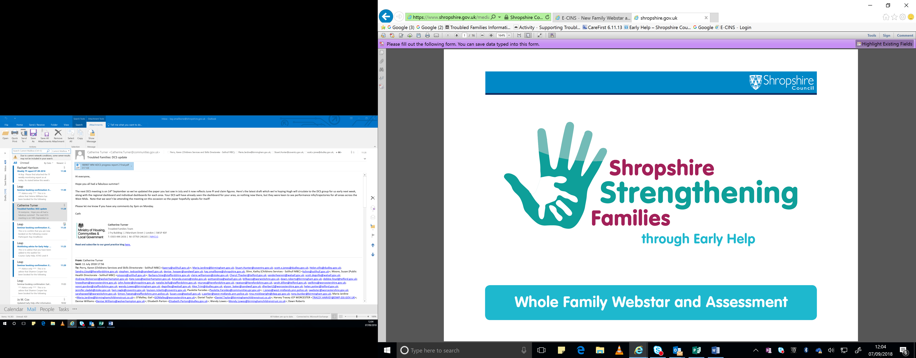

**Family Name**

**Family Members**

**Professionals contributing to the assessment**

**Date assessment completed**

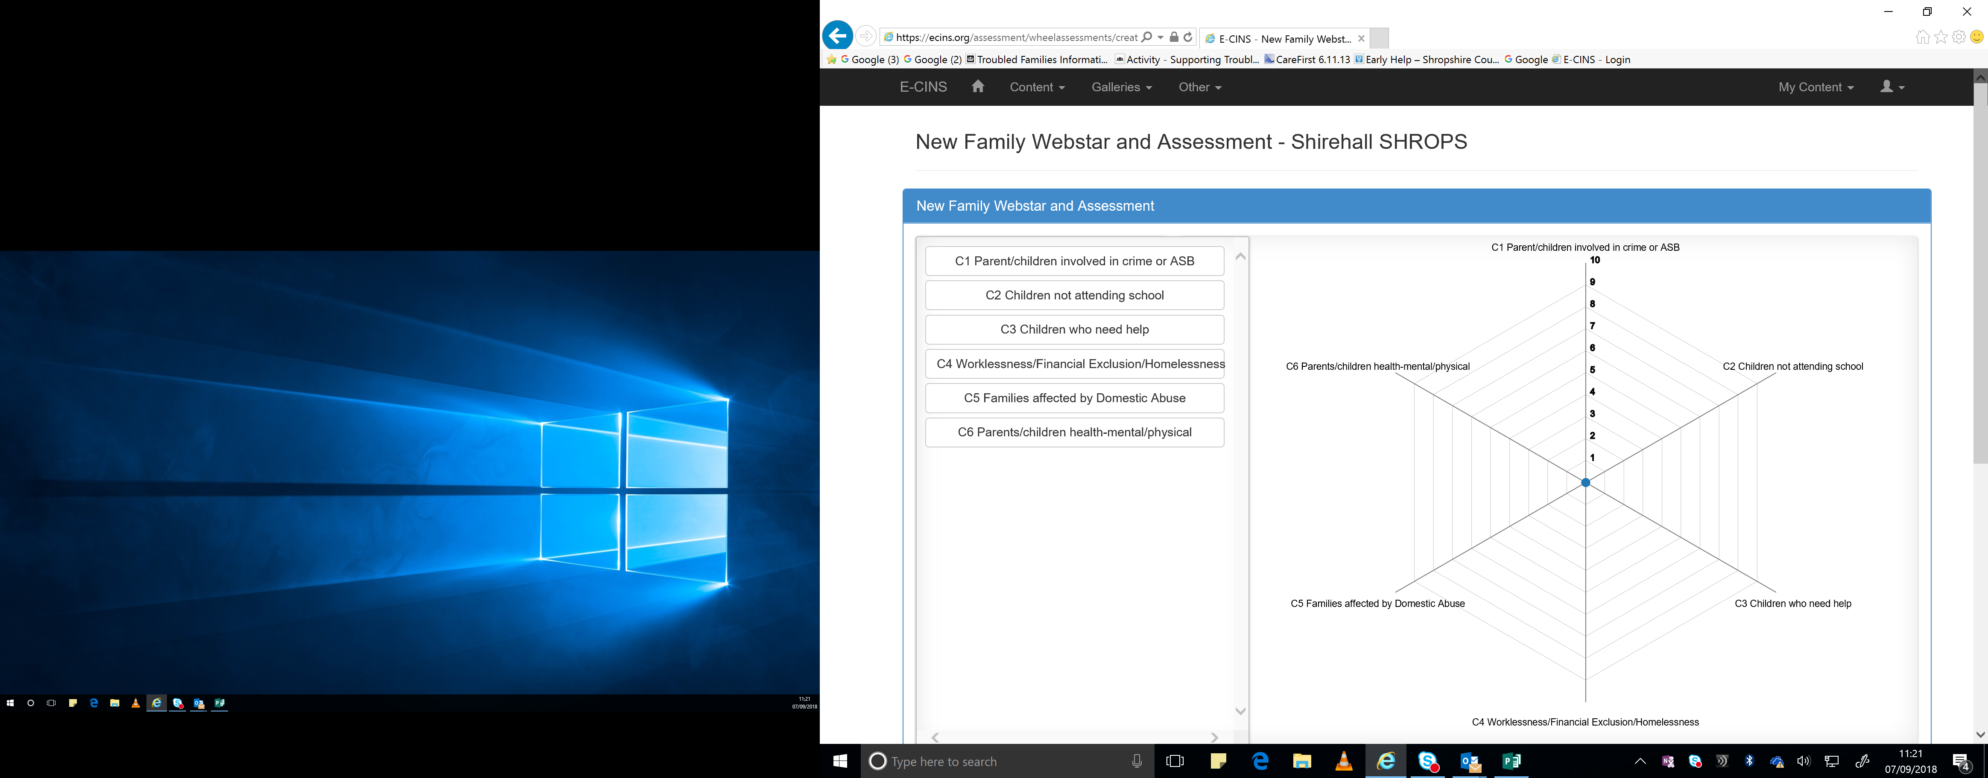

**Remember 10 is good**

**C1 – Parents or children involved in crime or anti-social behaviour**

**Past**

**Future**

**Present**

**C2 – Children who have not been attending school regularly**

**Past**

**Present**

**Future**

**C3 – Children of all ages who need help**

**Past**

**Present**

**Future**

**C4 – Adults out of work or at risk of financial exclusions/young people at risk of worklessness (NEET)/Families at risk or are homeless.**

**Past**

**Present**

**Future**

**C5 – Families affected by Domestic Abuse**

**Past**

**Present**

**Future**

**C6 – Parents and children with a range of health problems physical/mental**

**Past**

**Present**

**Future**

**Comments and Conclusions**

**Past**

**Present**

**Future**