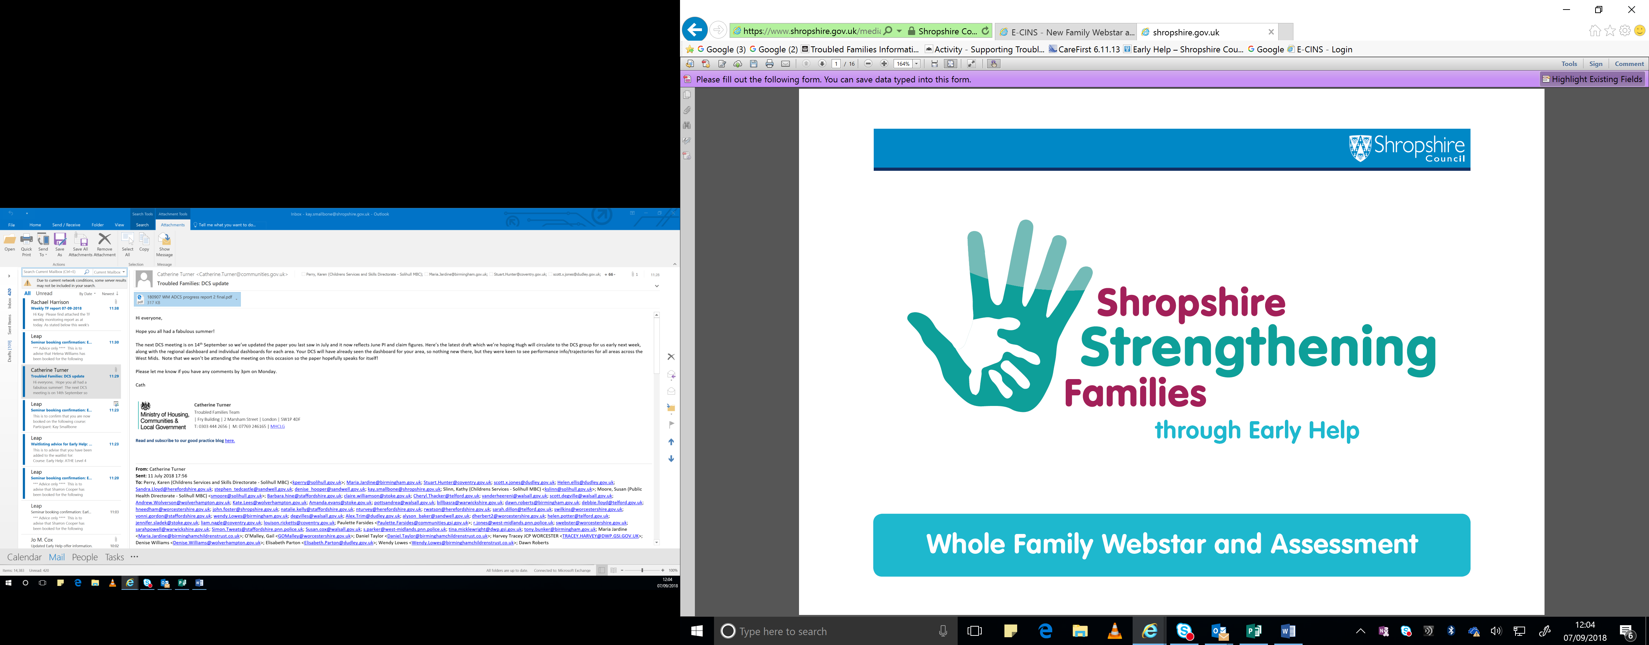

**Family Name**

**Education, Health and Care Plan (EHCP) Yes/No**

**Child/children’s name**

**Special Educations Needs and or Disabilities (SEND) Yes/No/Details**

**Professionals and Family members contributing to the assessment**

**Date assessment completed**

**C1 – Parents or children involved in crime or anti-social behaviour**

**Are there concerns about this criteria? Yes/No**

**Describe the family history regarding C1**

**Describe the family’s current situation, including strengths, what is working well, and what support is currently in place**

**What needs to change?**

**How would the family rate their situation against this criteria – 1 is poor and 10 is good**

**C2 – Children who have not been attending school regularly**

**Are there concerns about this criteria? Yes/No**

**Describe the family history regarding C2**

**Describe the family’s current situation, including strengths, what is working well, and what support is currently in place**

**What needs to change?**

**How would the family rate their situation against this criteria – 1 is poor and 10 is good**

**C3 – Children of all ages who need help**

**Are there concerns about this criteria? Yes/No**

**Describe the family history regarding C3**

**Describe the family’s current situation, including strengths, what is working well, and what support is currently in place**

**What needs to change?**

**How would the family rate their situation against this criteria – 1 is poor and 10 is good**

**C4 – Adults out of work or at risk of financial exclusions/young people at risk of worklessness (NEET)/Families at risk or are homeless.**

**Are there concerns about this criteria? Yes/No**

**Describe the family history regarding C4**

**Describe the family’s current situation, including strengths, what is working well, and what support is currently in place**

**What needs to change?**

**How would the family rate their situation against this criteria – 1 is poor and 10 is good**

**C5 – Families affected by Domestic Abuse**

**Are there concerns about this criteria? Yes/No**

**Describe the family history regarding C5**

**Describe the family’s current situation, including strengths, what is working well, and what support is currently in place**

**What needs to change?**

**How would the family rate their situation against this criteria – 1 is poor and 10 is good**

**C6 – Parents and children with a range of health problems physical/mental**

**Are there concerns about this criteria? Yes/No**

**Describe the family history regarding C6**

**Describe the family’s current situation, including strengths, what is working well, and what support is currently in place**

**What needs to change?**

**How would the family rate their situation against this criteria – 1 is poor and 10 is good**



**If a safeguarding risk is identified, what is the likelihood/seriousness? How can risks be reduced or managed?**

**Are the family at risk of homelessness?**

**Details**

**Yes/No**

**Is there a young carer in the family?**

**Details**

**Yes/No**

**Details**

**Yes/No**

**Are the family happy for the fire service to complete a home safety check?**

**Details**

**Yes/No**

**Has worklessness been identified?**

**Details**

**Yes/No**

**Is there a child or young person in the family at risk of exploitation?**

**Signed - Parent**

**Signed - Worker**