Visit: https://inourplace.co.uk/
Parents and carer can choose a language from the drop down menu to make it easier to navigate around the page.
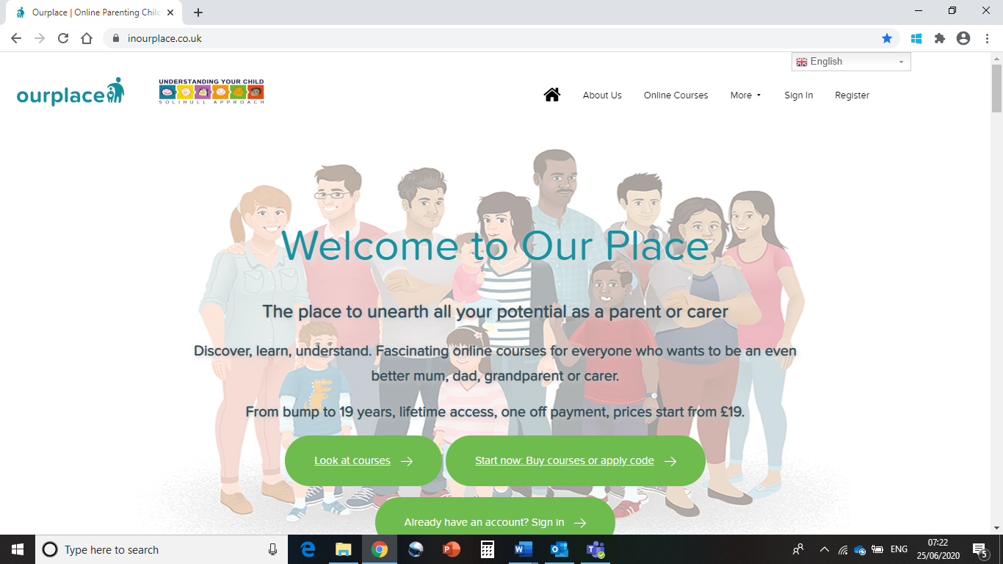

Once they have signed up/logged in they can then choose a language from the Google bar on the left. 108 languages in total.
The page as well as written course content is then translated into the chosen language. Please be mindful that Solihull Approach takes no responsibility for the correctness of these translations.
The courses which are offered in Welch, Urdu, Bulgarian, Polish, Arabic, Chinese on the Solihull webpage have been specifically translated by a professional translation service.
Attachments within the online course, which can be printed out, the voice over and video clips are still in English. However for the YouTube clips the parent/carer can go to settings and set captions in a variety of languages.
