Shropshire Strengthening Families/Early Help

How do we collect information from you and for what purpose?
The purpose of this form is to ensure your family consent to complete an assessment and to explain how information may be shared with partner agencies to provide you with specific services (for example; health, housing, education, children’s services, police, early years providers). The information is held securely on a case management system to ensure your family receive the best support services available.
All information collected and shared will be done so in order to:
- To provide and operate our Early Help Service and
- To provide you and your family with services that support and help your family.
We will treat information as confidential and we will not sell or rent your information to third parties. We will not share your information with third parties for marketing purposes.
Full details about how the Council will use your information can be found on our website at: www.shropshire.gov.uk/privacy - and the Strengthening Families Privacy notice can be found on the Early Help Website https://shropshire.gov.uk/media/14775/strengthening-families-privacy-notice.pdf

Name of professional supporting the completion of this consent form
Address and postcode

Main family contact telephone number | Main family contact email address

Please list all members of the household living at the address (over 13’s to sign individually).
Column Name (First name/family name)
Date of birth
Gender
Ethnicity (See codes below)
Additional needs and or disabilities
First language spoken
National Insurance number
Signature
Date
Relationships: Please complete or the demographics for the family cannot be finalised. For example see page 5.
Name (First name/family name) Column name relationship to row name
Relationships:
Self | Mother | Father | Daughter | Son | Wife
Husband | Sister | Brother | Ex Wife | Ex Husband | Half Sister
Half Brother | Mother’s Partner | Father’s Partner | Partner’s daughter | Partner’s son | Step mother
Step Father | Step daughter | Step Son | Step sister | Step brother | Grandmother
Grandfather | Granddaughter | Grandson | Step Grandmother | Step Grandfather | Step Granddaughter
Step Grandson | Great grandmother | Great grandfather | Great granddaughter | Great Grandson | Aunty
Uncle | Niece | Nephew | Cousin | Mother in Law | Father in Law
Daughter in law | Son in Law | Sister in Law | Brother in Law | Carer | Cared for
Adoptive Mother | Adoptive Father | Adoptive daughter | Adoptive son | Friend | Foster carer
Foster child | Private Foster carer | Private Foster Daughter | Private Foster son | Other – please state
Ethnicity Codes:
White: | Mixed/Dual Background: | Asian or Asian British: | Black or Black British: | Chinese:
- White - British | - White and Black Caribbean | 10. Indian | 14. Black Caribbean | 17. Chinese
- White – Irish | - White and Black African | 11. Pakistani | 15. Black – African
- Traveller of Irish Heritage | - White and Asian | 12. Bangladeshi | 16. Any other Black background
- Gypsy/Roma | - Any other Mixed background | 13. Any other Asian background |  | 18. Any Other Ethnic Group
- Any other White background

Consent to the Early help assessment taking place and how your information will be used

It has been explained how our information will be used and a copy of the Privacy Notice has been provided?: https://shropshire.gov.uk/media/14775/strengthening-families-privacy-notice.pdf
We/I consent to me/my family taking part in an early help assessment and to receiving support and help through this and to copies of your Early Help documentation being stored safely on Shropshire Council’s central system, Liquid Logic
We/I understand that in order to provide you with the early help support and services, information may be shared with partner agencies for example health, housing children’s services, early years providers and police, and used for the sole purposes of providing your family with services that support and help your family.
Is there any individual person or agency that you do not wish information to be shared with? If so please provide details here:
We/I understand that agencies (for example, health, housing, education, children’s services, and police) may discuss our family’s needs and that we/I will be provided with feedback from these discussions.
We/I understand that by agreeing to the assessment some of our personal information may be collected and shared with The Ministry for Housing Communities and Local Government and The Office of National Statistics for evaluation purposes and that all findings will be anonymised.
We/I understand we/I can withdraw my consent to the early help service and assessment at any time in writing to the Lead Professional.
We/I understand that a request to see our personal information can be made.

Parent/Carer Signature |  | Name |  | Date
Professional Name |  | Organisation |  | Date
Professionals Signature |  | Job Title
Professionals contact details | Phone Number |  | E-mail address

Guidance notes

- Please make sure every member of the household is included on this form where possible even if they do not sign.
- Please ensure that the relationship section is completed for all members of the household. Example below.

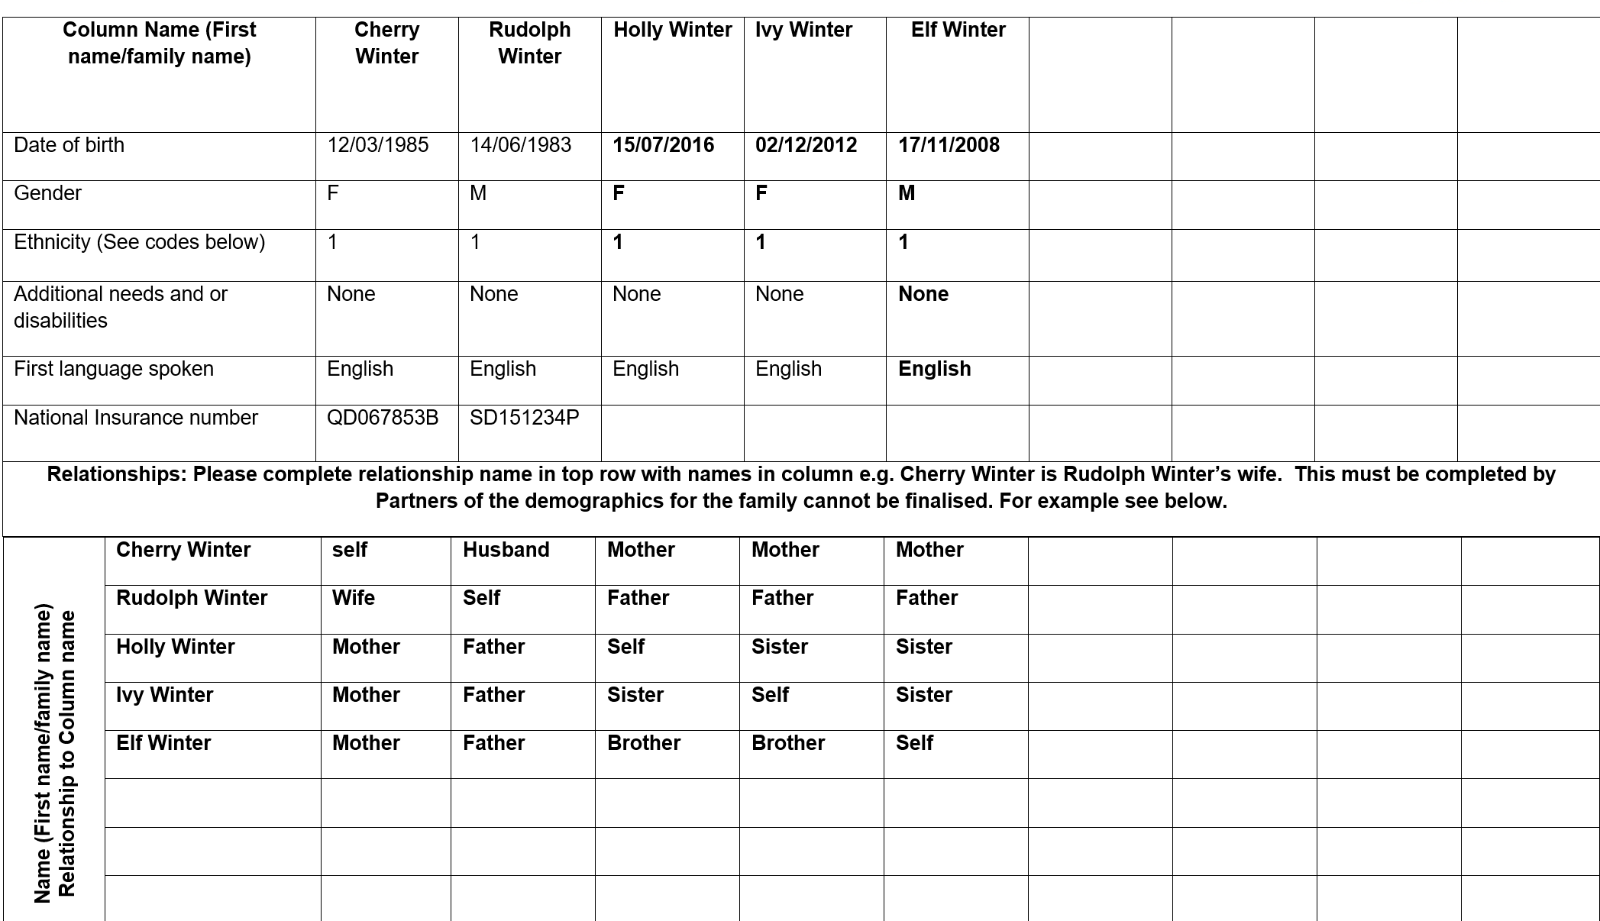
Cherry is the wife of Rudolph
Cherry is the mother of Holly
Cherry is the mother of Ivy
Cherry is the mother of Elf

- If other members of the family need to sign please make a copy and ask for it to be signed and returned
- Please ask the family if they would they would like a copy of the completed form.
- Please clarify the family’s understanding of the form, including how their information will be shared.

Please complete all sections of the form and send to ShropshireStrengtheningFamilies@Shropshire.gov.uk using an encrypted email. A case will be created for you and access given to the Lead Professional identified on this form. You will then need to follow the workflow complete the assessment and plan as appropriate.

