Key Worker – Personal Assistant

Name of Employer:

Address:

Name of Personal Assistant (PA)

Address:

This letter has been issued to people who use a direct payment to manage their social care and support needs (the Employer).

The letter should be used to provide evidence that the named personal assistant is a key worker according to the Government’s guidance.

The personal assistant named above is responsible for supporting me to maintain my daily living needs, this includes shopping for essentials, collecting prescriptions, and assisting with medical appointments as well as providing care and support in my home or the community.

This support is funded, or part funded by Shropshire Council through a direct payment.

Signed by or on behalf of (employer)

Date:

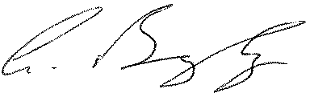

Andy Begley
Chief Executive on behalf of Shropshire Council

