Eastern European Communities – Toolkit
(updated 27.05.2021)

Key messages - general
- Vaccines prevent up to 3 million deaths worldwide every year

- After clean water, vaccination is the most effective public health intervention in the world

- Vaccines teach your immune system how to create antibodies that protect you from diseases

- Since vaccines were introduced in the UK, diseases like smallpox, polio and tetanus that used to kill or disable millions of people are either gone or seen very rarely.

- Vaccines are the way out of this pandemic. An effective vaccine is the best way to protect people from coronavirus.

- Following extensive safety trials and authorisation by the independent regulator, the MHRA, effective COVID-19 vaccines are available in the UK for free.
- The NHS will contact people in the priority groups when it is their turn to receive the vaccine. People are being called forward who meet the criteria based on the Joint Committee on Vaccination and Immunisation’s recommendations.
- The vaccine cannot give you the COVID-19 infection, and it will reduce your chance of becoming seriously ill.
- Like all medicines, vaccines can cause side effects. Most of these are mild and short term, and not everyone gets them.
- The most common side effects include:
      - a painful, heavy feeling and tenderness in the arm where you had your injection
      - feeling tired, general aches, or mild flu like symptoms
      - a headache

- The public have an important part to play:
- please don’t contact the NHS to seek a vaccine, the NHS will contact you;
- when we do contact you, please attend your booked appointments; and
- please continue to follow all the guidance to control the virus and save lives.

- Whether or not you have had the vaccine you still need to:
- practice social distancing
- wear a face mask
- wash your hands carefully and frequently
- follow the current guidance

Key messages – second dose
- If you had your first Covid-19 vaccination 11 to 12 weeks ago, you should make sure you receive the second part of your vaccination to get maximum protection.

- The NHS has been planning meticulously to ensure that people can get that second part of the vaccine when it is the right time for them to do so, and all vaccination services have supply

- The first dose of both the Pfizer/BioNTech and Oxford/AstraZeneca vaccine offer good levels of protection, but everyone needs the second part of their vaccination to get maximum protection from COVID-19

- Please come forward for the second part of your vaccination when you are contacted or if you have an appointment booked

- If you received your first part of your vaccination in a hospital hub or through a GP service, you will be contacted to receive the second part. You do not need to contact the NHS.

- If you booked your appointment through the national booking service (online at www.nhs.uk/covidvaccine or by ringing 119) you will have booked both your first and second appointments at the same time

- If you rang 119 you will have been given details of your second appointment over the phone

- If it is three calendar months since the first part of your vaccination and you have not received a second appointment, please contact your GP or go to Book a coronavirus vaccination - NHS (www.nhs.uk)

- Unless there are exceptional circumstances, everyone should have their second part of the vaccination in the same place where they had the first part of the vaccination

- If people are concerned about the second part of their vaccination, then they should contact their GP, or http://www.nhs.uk/covid-vaccination

Key messages – Astra Zeneca vaccine
- The Astra Zeneca vaccine has been approved as safe for use by the MHRA (the Medicines and Healthcare Regulatory Agency)

- The benefits of having the Astra Zeneca vaccine by far outweigh the risks for the vast majority of people

- People should continue to have the Astra Zeneca vaccine when it is offered to them

- Blood clots following the first dose of the Astra Zeneca vaccine are extremely rare (affecting around 4 in 1 million people)

- For healthy people under the age of 40, who are unlikely to have severe Covid-19 symptoms, national advice is for them to have another type of vaccine if this is available

- It is important that everyone of any age who has had their first vaccine dose (including Astra Zeneca) without a severe reaction* should have their second dose; this should be with the same vaccine as the first dose

- Patients who had a severe reaction after their first vaccine dose or who are under the age of 40 with an underlying condition should discuss the risks and benefits with their GP
* A normal reaction includes a sore arm, feeling achy and/or tired, having a headache or flu-like symptoms

Key messages - Women who are pregnant, breastfeeding or thinking of starting a family
- The latest advice from the Joint Committee on Vaccination and Immunisation (JCVI) is that COVID-19 vaccines should be offered to pregnant women at the same time as the rest of the population, based on their age and clinical risk group.

- Women should discuss the benefits and risks of having the vaccine with their healthcare professional and reach a joint decision based on individual circumstances

- You can have the COVID-19 vaccine if you're breastfeeding.

- Women who are trying to become pregnant do not need to avoid pregnancy after having the vaccine. The vaccine cannot give you or your baby COVID-19.

Further information about Covid-19 vaccines and pregnancy: Royal College of Obstetricians & Gynaecology https://www.rcog.org.uk/en/guidelines-research-services/coronavirus-covid-19-pregnancy-and-womens-health/covid-19-vaccines-and-pregnancy/

Leaflets
English
- Leaflet for adults
- Leaflet for women of childbearing age
- Leaflet about the Astra Zeneca vaccine and blood clotting
Albanian
Bulgarian
Lithuanian
Polish

Romanian
Translated Videos - Bulgarian
Local resident: Covid 19 vaccine Bulgarian https://www.youtube.com/watch?v=9JNlZrNLBcE&list=PLNXsxVcdCXuHEte0GbRQw0edt2tLl0xfV&index=25
Dr Plamena: Covid 19 vaccination Bulgarian https://www.youtube.com/watch?v=6kIumtmDQMc&list=PLNXsxVcdCXuHEte0GbRQw0edt2tLl0xfV&index=27
Dr Plamena: Astra Zeneca Bulgarian https://www.youtube.com/watch?v=b7jkVXDBNag&list=PLNXsxVcdCXuHEte0GbRQw0edt2tLl0xfV&index=30

Resources to support those with dementia, their families and carers
Polish - https://raceequalityfoundation.org.uk/health-care/covid-19-translated-materials-resources/#Polish-Translated-Materials-

Coronavirus information translated into different languages – Doctors of the World https://www.doctorsoftheworld.org.uk/coronavirus-information/

Social media assets
Polish
Fact checker
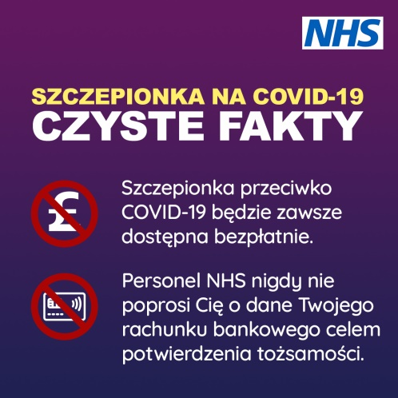
Vaccine safety testing
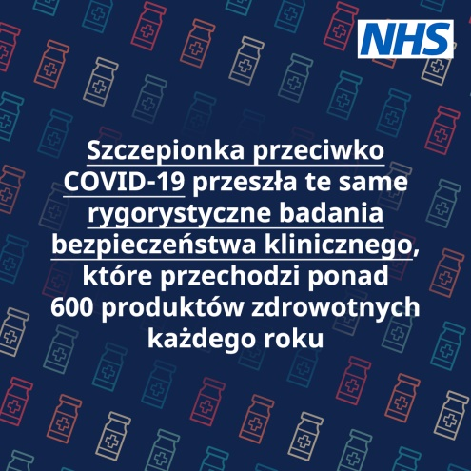
Can’t catch Covid
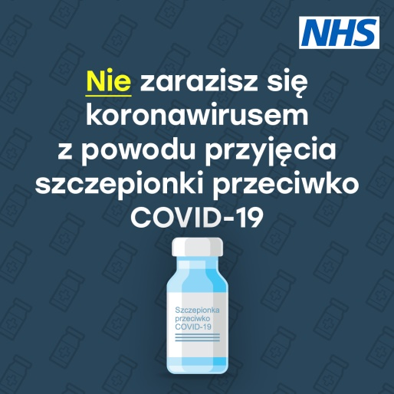
Romanian
Vaccine safety testing
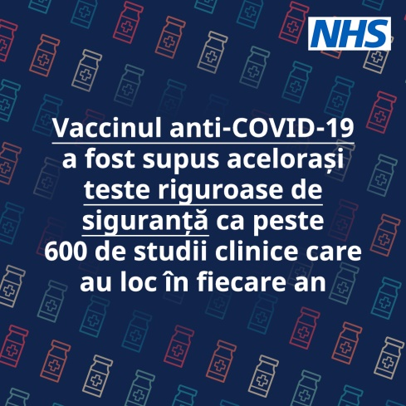
Can’t catch Covid
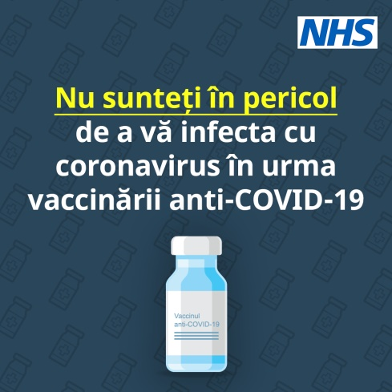
Fact checker
