Targeted
provision:
Level of need 3
Targeted
provision: Level
of need 2 & 3
Universal
provision:
Level of need 1
Knowing your child:
Observations,
discussions with
parents, colleagues
and other agencies
•
Severe delay in one or more areas of
development including sensory processing
•
Severe social and emotional difficulty
•
Known to Health and other agencies
•
Moderate level of need were the
child is not making expected progress
in more than one of the prime areas
•
Behaviour impacting on child
accessing learning
•
Long term physical or sensory need
•
Not making expected progress in one
of the prime areas
•
Behaviour causing concern
•
Some social anxieties
•
Children with a recent upset or change
in home circumstances
•
Medical condition
When a need is identified the child must have an
sen support plan
➢ | Use the support request form to share concerns
➢ | Start the Early Years support plan
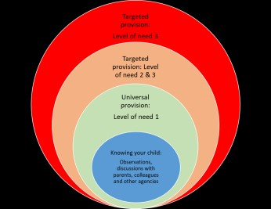
Actions by the setting
Severe delay in one or
more areas of
development including
sensory processing
Severe social and
emotional difficulty
As below
Support parents to get referral to
Paediatrician through PHN or GP
Deliver interventions and use
strategies to work on targets and
outcomes set by other agencies
or the EHCP
Identify staff training
needs
Plan use of adults and
adaptations to your
environment based
on targets set in the
support plan
Moderate level of need where
the child is not making expected
progress in more than one of
the prime areas
Behaviour impacting on child
accessing learning
Long term physical or sensory
need
As below
Contact Public Health
Nurse team
Consider referral to other
agencies
Discuss with sen team
regarding possible referral
to Paediatrician
Plan use of more
targeted
interventions and
strategies to support
inclusive practice
and independence
with key person and
adult
-
led activities
Not making expected
progress in one of the
prime areas
Behaviour causing concern
Some social anxieties
Children with a recent
upset or change in home
circumstances
Medical condition
Discuss with parent/carers
Start Early Years support
plan
Implement advice from
Health professionals
Consider training needs
Look at universal
offer for all children
in your setting

