Shropshire Refuse and Recycling

Advice for Developers

2022 Update

Contents:

1.0 Refuse and recycling Background Information
1.1 Introduction
2.0 Planning and design
2.1 Good Practice
2.2 Internal storage facilities for waste prior to collection
3.0 Shropshire Waste and Recycling Services
3.1 Domestic Waste and Recycling collections
3.2 Capacity Requirements for households
3.3 Container Dimensions
3.4 Domestic Properties- Houses
3.5 Domestic Properties – Flats and Apartments
3.6 Mixed Use Developments
3.7 Other
4.0 Collection Specification
5.0 Vehicle Specifications
6.0 Contacts
7.0 Vehicle Data

1.0 Refuse and recycling planning guidance background
This advice note has been prepared to assist developers by highlighting Shropshire Council’s current management of refuse and recycling collections and what provisions will be expected when proposals for new dwellings come forward in the future.

1.1 Introduction
Shropshire Council is committed to reducing the amount of waste sent for disposal and to maximise reuse and recycling: To this end we offer a collection of kerbside recycling, and garden waste* as well as household waste to all properties within the county with a wide range of recyclable materials collected. To ensure that we meet the objectives outlined above it is vital that new buildings are designed to provide facilities that ensure waste can be managed safely, efficiently, and effectively, for segregation of recycling, and to be stored and collected in such a way that is suitable to all parties involved.

This guidance has been developed by the Council’s Waste Management Unit in consultation with Planning Services and other relevant departments to assist developers in relation to:

- Single houses or developments of 2 or more houses
- Facilities within individual or groups of properties or premises for the separation and storage of waste for collection recycling and for composting.

The Council’s refuse and recycling service is reviewed on a regular basis and applicants/agents are advised to contact Shropshire Council‘s Waste Management Unit to ascertain that the details outlined within this document are still applicable at the time.

2.0 Planning and Design
This guidance should be referred to from the earliest stages of building design. The provision of an effective and efficient refuse/recycling service is a key Council operation, and it is essential that the needs of this service are considered at the earliest design stage for new residential and householder developments. All new developments shall be designed so that waste and recycling issues are fully considered as part of the pre-planning application process. Adequate storage areas for waste management facilities is essential and good access for collection crews and vehicles can be difficult to retrofit at later stages in the design process.

Applications for new developments should be accompanied by a concise waste management report that addresses relevant aspects of this guidance. A report of this nature will enable this element of the development to be dealt with in a comprehensive and efficient way, and it need not be particularly lengthy or expensive to prepare. The report should clearly set out the measures proposed to be taken to ensure waste reduction and recycling provision within the new development and must include a vehicle tracking plan to confirm that the waste collection vehicles can access the properties. Relevant officers will be happy to discuss the contents and format of the report at the pre-application stage.

2.1 Good Practice
There are a number of factors which need to be taken into consideration when designing refuse and recycling storage facilities for flats/apartments, and housing developments to ensure safe, efficient collection by the collection vehicles/operatives and as a means of encouraging use by residents.

Adhering to methods of good practice and following guidelines laid out in this document will help to achieve both of these things.

Forward planning with regard to refuse and recycling storage and collection will provide benefits to developers, residents, and the Council. Developers able to disguise and screen bin areas make developments more attractive to potential buyers. For flats and apartments ensure residents are provided with secure bin areas for communal use which decrease the risk of contamination and vandalism allowing a more effective collection operation. In all situations refuse and recycling materials collection facilities shall be protected from the weather, well ventilated and light.

2.2 Internal Storage.
To encourage occupants to recycle their waste, internal storage facilities for recycling, prior to collection, should be designed into each property/unit to enable householders to sort and store their recycling prior to placing it in the collection boxes. To avoid issues with odour it is best practice to have ventilation included in fully enclosed bin stores.

3.0 Shropshire Council’s Waste and Recycling Service Specification
Further information is also provided at Recycling and rubbish | Shropshire Council

3.1 Domestic waste and recycling collections
Please note that for most properties all collections take place on the same day of the week, details on the collection day for a property or street, go to our website homepage – waste collection day finder or contact Shropshire Council’s Customer Service Centre on 0345 6789 9007. Note that new build collection days could vary from neighbouring properties – if in doubt please ask.

Shropshire Council’s current household collection scheme is based on the provision of wheeled bins for residual waste, garden and Recycling (plastic, cans and glass) and a 72 Litre Woven bag for cardboard and paper, all of which are collected on a fortnightly basis as per the collection calendars.

Collection normally occurs from the edge of the property (curtilage) or such other collection point as has been agreed with the Council, developer and resident. In the case of shared units with communal wheeled bins the collection occurs from the designated bin store or storage area.
The standard collection service consists of:
Residual collection – the standard container is 240ltr wheelie bin (black) or 360 litre (capacity) where there are 6 or more people living in the house (by special request).
Recycling collection – the standard 1 x 240Ltr wheelie bin (purple lidded) and 70L reusable blue bag.
Garden Waste Collection – All properties are entitled to 1 x 240 litre garden waste wheelie bin. Shropshire Council also offers residents the option of paying an annual charge for an additional 240 litre garden waste wheelie bin service.

*Food Collections are available in certain areas – food is accepted within the green waste collection containers in former North and South Shropshire and Shrewsbury areas. Confirmation of this can be found on the calendars or via the Council website.
Your collection service | Shropshire Council
Communal recycling and refuse containers - where developers opt for traditional bin stores waste collection is usually from 1100ltr containers for mixed plastic, cans, and glass and 360 Litre containers for card and paper. An allowance for an additional special 240 Litre container should be allowed for food waste in the areas mentioned above *Please refer to the specific guidance in section 3.2 and 3.5 regarding communal collections

3.2 Capacity and storage requirements For Households
The Council requires that all residential developments incorporate at least sufficient external storage space for refuse and recycling for the current service.

Storage must also be sufficient to allow for the storage of additional recycling materials/containers that Shropshire Council may collect in the future. Provision for compost bins in gardens should also be considered.

Any storage areas should be sensitively located and designed to fit in with the local environment. New and existing developments should take into account the visual impact of the bins and their enclosures.
They should also include adequate ventilation to prevent smells

Number of properties | Number of containers required for refuse | Number of containers required for recycling
Individual houses | 1 x 240 litre bin (black) or where 6 or more people are resident 1 x 240 litre bin + 140 litre bin | 1 x 240 litre green bin for garden waste  1x 240 litre wheeled bin for mixed recycling  (Plastic, cans, glass).  1 x 72 litre blue woven sack for cardboard and paper.
Communal Bin Store servicing 1-5 properties | 1 x 1100 litre bins | 1 x 1100 litre bin for Mixed recycling  1 x 360 Litre bin for card and paper
Communal Bin Store  servicing 6-10 properties | 2 x 1100 litre bins | 1 x 1100 litre bin for Mixed recycling  2 x 360 Litre for card and paper
Communal Bin Store servicing  11-15 properties | 3 x 1100 litre bins | 2 x 1100 litre bin for Mixed recycling  3 x 360 Litre for card and paper
Communal Bin Store servicing 16-20 properties | 4 x 1100 litre bins | 2 x 1100 litre bin for Mixed recycling  4 x 360 Litres for cardboard and paper

3.3 Container dimensions

Container | Dimensions (mm) | Min floor space required
140 litre wheelie bin | Width – 560  Depth – 558  Height – 1054 | 570 x 570
240 litre wheelie bin | Width – 720  Depth – 734  Height – 1063 | 730 x 750
360 litre wheelie bin | Width 760  Depth 880  Height 1100 | 770 x 900
1100 litre wheelie bin | Width – 1375  Depth – 1000  Height – 1470  Height with lid open - 2470 | 1575 x 1300

Please remember to allow adequate room for access to the containers and surfaces should be smooth between the storage location and the collection point

3.4 Domestic Properties - Houses
The containers required must all be stored within the boundary of the property and the storage space must bear relation to the size of the number of householders/occupants.

Householders are expected to present their waste and recycling at the kerbside for collection on the scheduled day and any containers returned to the property as soon as possible but no later than the end of the collection day. Containers should therefore be stored at the property in a position that is convenient for the householder to present them at the kerbside for collection and located away from windows and ventilators to avoid any nuisance odours entering the premises. To minimise noise disturbance and visual intrusion containers should be located 6 metres from buildings/windows.

Storage areas should also be readily accessible to the collection crews in order to accommodate any assistance required in presenting the waste which may be required in the future by owners.

For homes with front gardens where no rear access is proposed, well designed refuse and recycling storage facilities should be provided in covered areas capable of accommodating the bin requirements at time of construction, with the facility to completely lift the bin lid in situ and permitting the separate collection of recyclable materials

3.5 Domestic Properties - Flats and Apartments
Containers should be stored in a designated external storage area which has been sensitively located and designed to provide easily accessible and mutually convenient waste storage for the householders and the collection crews. The storage area should be close to the point of collection.

Doorways should provide at least 1.3m clearance (including thickness of doors). A walkway of at least 1.3m should also be provided within the store without the need to move any other container.

It is the responsibility of the caretaker/management company (or similar) to allow access to individual containers, enabling each to be removed from the store to allow the collection crews access to the container stores/collection point on collection day and to ensure that access is not restricted, for example by parked cars. If a bin store is fitted with locks, then four sets of keys or fobs (and replacement sets as required) must be supplied to Shropshire Council’s Waste Management contractor Veolia at no cost. Combination locks have proved to be effective for this purpose. Entry code(s) to be provided to Veolia.

Within storage facilities, a minimum clearance of 150 mm is required around all sides of the bins, and these should be placed side by side, so residents are not inconvenienced accessing other bins. The entrance doors should have a minimum height of 1.8m to allow ease of access for both residents and operatives and a minimum of 2.5 metres from floor to ceiling to ensure the lids on all containers can be opened fully.

The location of bin storage should take account of risk from fire and the impact of smells in relation to adjoining residential properties, and to minimise noise disturbance and visual intrusion from buildings/windows.

Where communal bins are proposed it is essential that any bin store is located immediately adjoining the road that the collection vehicles will use. Access to and not within the communal parking areas (unless these are adopted and can provide the necessary turning circle). Where flats are proposed, a communal recycling local facility should be provided at a convenient location for both residents and collection operatives.

Collection points should be sited clear of any road and pavement/cycleway and should be flat and made of hard surfaced material that compliments the surrounding environment. They should be of a size that will be capable of accommodating the required number of bins/recycling boxes so there is no overflow onto the public right of way.

3.6 Mixed Use Developments
Mixed use developments should have separate stores for refuse and recycling containers. Commercial properties should provide separate areas for waste collection (and clearly labelled).

(No mixing of commercial waste and residential waste is permitted)

3.7 Other
Consideration should be given to composting facilities within new developments (including the communal gardens space in multi-occupation premises) as treatment of waste at source is recognised as the most sustainable method of treatment. Gardens should, where possible, be laid out so that sufficient space is allowed for home composting.

It should be noted that the waste and recycling provision is an evolving service.Developers should contact the Council’s Waste Management Section for specific advice on recycling collection arrangements.

4.0 Collection Specification

- Residents should not have to pull/push bins or carry waste for more than 25 metres
- Collection crews should not have to push/pull 2 wheeled containers or carry individual waste containers more than 15 metres (from the collection point for the vehicle)
- Collection crews should not have to push/pull 4 wheeled containers more than 10 metres
- A safe stopping bay or equivalent should be provided with sufficient turning area and manoeuvring space for the collection vehicle. (This will be as standard in general planning guidance for our vehicles)
- Recycling bins should be located with refuse bins and clearly labelled
- Collection vehicles cannot collect containers that are on a slope. The gradient of a slope that containers need to be moved over must not exceed 1:12.
- Surfaces that containers need to move over shall be of a smooth continuous finish and free from steps or other obstacles. Any steps shall incorporate a drop-kerb.
- Space allocated for bin storage should not have bins stored more than one deep and should provide ample room for rotating the bins
- Overhead service cables, pipes, archways and other potential obstacles must be at least 7m from ground level
- Collection vehicles should not reverse into developments from a major road or reverse onto a major road when exiting the development

Collection operations should take all appropriate steps to design out manual handling and the requirement for vehicle reversing when designing collection operations. The British Standard guidance document BS5905:2005 states that the distance collectors should have to cover in respect of transporting waste containers to and from the collection vehicle should be minimised to achieve an economical service. The collector should not be required to carry individual waste containers or move two wheeled containers for more than 15 metres, nor to manoeuvre four wheeled waste storage containers from the storage points to the collection vehicle for more than 10 metres.

Where bulk containers are used, direct vehicular access to the containers is necessary. The collectors should not be required to move wheeled waste storage containers over surfaces that may hinder the smooth passage of the container. An adjacent storage area should be provided where many households use the same collection point, so as not to block the pavement.

These health and safety requirements must be incorporated into the scheme from the earliest design stage. The Council and their contractor are happy to give advice upon request.

5.0 Vehicle Specifications
The proposed layouts of larger scale developments should include a vehicle tracking plan indicating satisfactory vehicle manoeuvrability within the site to be developed and demonstrate that it has been designed to include an efficient refuse/recycling collection ‘round’, based upon the operating standards and vehicle dimensions.

The vehicles used are:

ECONIC 32 and 26 Tonnes

The tracking plan will need to be agreed with the Council’s Waste Management Department as collection authority and the Council’s Contractor, Veolia.

An example of a tracking plan is shown below.

The ‘round’ should be designed to allow the refuse collection (RCV)vehicle to operate in a forward gear only wherever possible; adequate turning facilities, large enough to accommodate the refuse collection vehicle, will be required where the RCV is unable to drive a circuitous route. Where the RCV will not be expected to have direct access, provision of collection points must be shown; designated collection points must be agreed with the Council’s Operations and Waste Management as part of the scheme design before an application is submitted.

To allow safe access, all roads, and other areas that are to be used by the RCV must be designed to withstand the full weight of the vehicle, which is 32 tonnes (max). Any archways etc. must have a minimum vertical clearance of 4.50 metres. Consideration must be made regarding trees, overhang, cables, balconies, barriers, and archways etc.

The width of any road where the RCV is expected to access will need to be a minimum of 5 metres, this will allow single side parking and the RCV to pass without hindrance. Consideration must be given at the initial design stage for the provision of adequate off-street parking in safe and convenient locations for residents to minimise parking within the street. Where developments are designed to have on street parking on both sides of a road, the minimum road width would need to be 8 metres. The RCV will only travel along roads that have been constructed to Council’s adoptable standards.

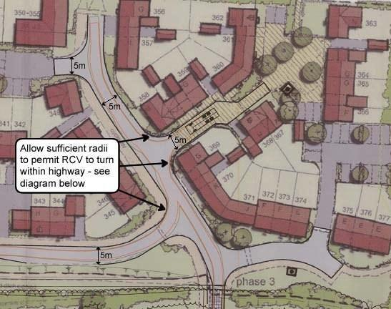

Example vehicle tracking plan. Orange lines indicate vehicle route

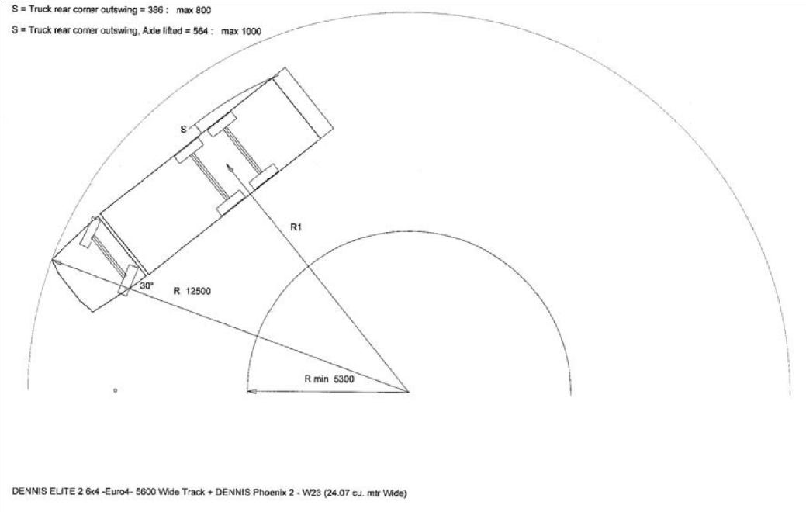
Example vehicle turning Specification

6.0 Contacts
Operations and Waste Management – for information on collections or any other questions email waste.management@shropshire.gov.uk

7.0 Vehicle Data (Typical)

Maximum typical dimension of collection vehicles

Vehicle Dimensions
 | 26 Tonne | 32 Tonne
Overall Length | 8600 | 9500
Turning circle | 20.0m | 22.5m
Height | 2950 | 2950

