Shropshire’s Warm Welcome
Communications toolkit

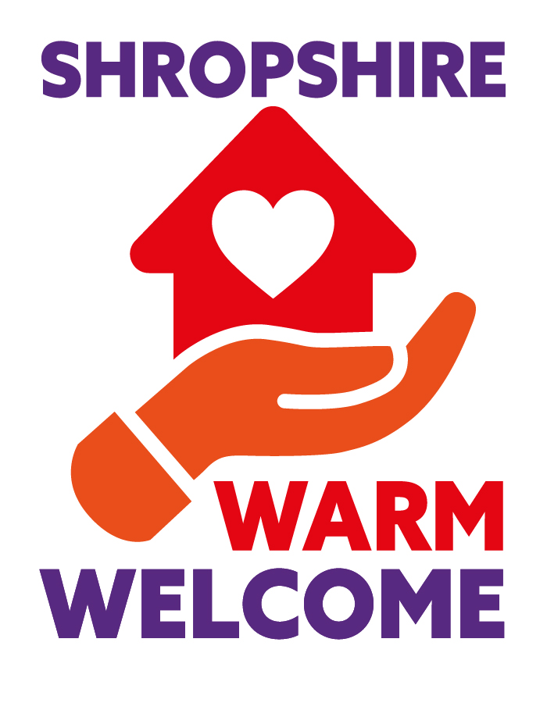

Contents Page

Introduction 3

About this toolkit 3

Key messages - What is Shropshire’s Warm Welcome 4

Key messages – cost of living 5

Press release 6

Graphics and logo 7

Social media 8 to 9

Introduction

To help residents stay warm and safe this winter, Shropshire Council and partners have complied a map of venues, including libraries, village and town halls, community centres and faith buildings, where residents can go during each venue’s normal opening hours to enjoy the facilities and keep warm.
You can find the map on Shropshire Council’s cost of living help pages. The map allows people to locate their nearest Warm Welcome and find out what’s on offer at each location.
Please feel free to use and adapt this information for your own channels.

About this communication toolkit

Thank you for supporting the Warm Welcome campaign – a collaboration between Shropshire Council and the community and voluntary sector.
This toolkit provides advice and information on how to raise awareness and promote the scheme to your audiences.
The toolkit also provides you with a range of communication materials including, key messages, articles, and social media messages for you to use and cascade to your staff, residents that you support, organisations that you work with, and the wider community.

Key messages
What is Shropshire’s Warm Welcome?

- Shropshire’s Warm Welcome is a range of council and community spaces where people can go for free this autumn/winter to socialise while also staying warm.
- If you are worried about the cost of heating your home, you can go along to a community space that is already nice and warm.
- Winter can be a lonely time for many people, but Warm Welcome will offer a friendly space to everyone.
- Shropshire Council is hosting a map on its website to signpost people to their nearest Warm Welcome. These include libraries, leisure centres and other community buildings.
- Every Warm Welcome is free, safe, and inclusive.
- Some locations will have activities, refreshments, Wi-Fi, charging abilities etc. Check map for what each Warm Welcome can offer and its opening times.
- Each location will bear the Warm Welcome logo, so you do not need to ask. Just turn up and find a seat.

Who is the Warm Welcome for?
- Everyone!
- Community spaces are there for residents. Go along, socialise, meet friends, and take part in any activities on offer etc while also keeping warm.
- Many of the warm welcome spaces are local libraries, which are great for individuals and families. Aside from books, they often have toys and games for children, free use of computers and wifi, clubs like IT support groups, interesting talks, information on community events, and much more. Some even have a free school uniform swap shop.

Benefits of warm spaces
- Keep warm in a safe and friendly place
- Find out what is going on in your community
- Socialise and improve your mental wellbeing
- Find out what other support is on offer

Tone to consider
- Acknowledge support from Government. E.g., Households to start receiving £400 off their energy bills from October and the £2,500 average energy price guarantee.
- Shropshire Council and partners in the voluntary and community sector realise some people/families may need more support this autumn/winter.
- You are not alone if you are worried about the cost of living crisis. There is help and support available.
- Great support network in Shropshire that can offer a Warm Welcome.
- Lots more help and support on offer from council and partners on the Shropshire Council website.

Important note about funding

- You need to be mindful you may be approached by residents who may ask why we don’t have the same funding as maybe some neighbouring local authorities.
Currently there is no national centrally funded grants or Government scheme that have been provided to local authorities to support our Cost of Living programme or provision of warm spaces. The only national funding we have received is the the Household Support Fund from government which is predominantly targeted and ringfenced to our most vulnerable households.
However, we are investigating one off funding sources for partners to support the warm welcome provision in Shropshire and will provide more information as soon as this is available.

Cost of living key messages

- If you or someone you know if struggling with the cost of living crisis, you are not alone.
- There is help available. We are working with our partners in the community and voluntary sector to signpost people to the help and support on offer.
- Don’t wait to ask for help. If you are worried, act now.
- For more information visit Cost of living help | Shropshire Council

Cost of living communication Toolkit for partners
To help you communicate the cost of living support, we have also pulled together a toolkit with key messages, an article, graphics and social media messages.

Press release
Please use this copy for newsletters, websites, staff intranets and any other appropriate communication channels you use. Feel free to also include a quote from your organisation to encourage people to access them.

A very Warm Welcome offered across Shropshire

More than 80 community spaces and council buildings are now offering a Warm Welcome to Shropshire residents this winter.

The colder months can be a lonely and challenging time for many people, especially those who may be worried about the cost of energy bills.

The Warm Welcome project is a collaboration between Shropshire Council and partners which highlights community venues where people can go for free to socialise, meet friends and take part in activities while also keeping warm.

A web page highlighting each Warm Welcome location, its opening times and what is on offer is now available on the Shropshire Council cost of living website.

Each location will bear the Shropshire Warm Welcome logo and is free to enter, warm, safe and inclusive.

Councillor Gwilym Butler, cabinet member for finance, said: “The colder and darker winter months can be a tough time for many people. Please know you are not alone. There are lots of community spaces open during autumn and winter where you can spend as little or as long as you like during their opening hours.

“Keep warm, meet new people or catch-up with friends and find out what kind of support is on offer in Shropshire. Some places, like our council libraries, will also have books, toys, games, free WiFi, interesting talks and more.”

You can find your nearest Warm Welcome here: Warm Welcome locations | Shropshire Council

If you are concerned about the rising cost of living, you can get support with energy, food, money, mental health and more, as well as read expert blogs, on our website.

There is also an online checklist residents can work through to ensure they are maximising their incomes and reducing costs where possible.

More information
- The cost of living advice and support is a partnership between Shropshire Council, Citizens Advice Shropshire, Marches Energy Agency, Shropshire Food Poverty Alliance, Age UK, Community Resource, The Shropshire Voluntary and Community Sector Assembly and Shropshire Mental Health Support.

Graphics
The graphics and logo below can be used in your communications, newsletters and social media posts. You will also find the cost of living graphics in our cost of living communication toolkit.
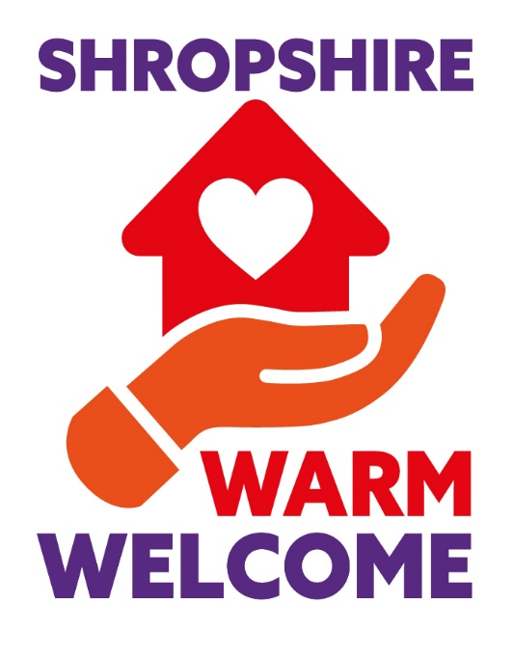

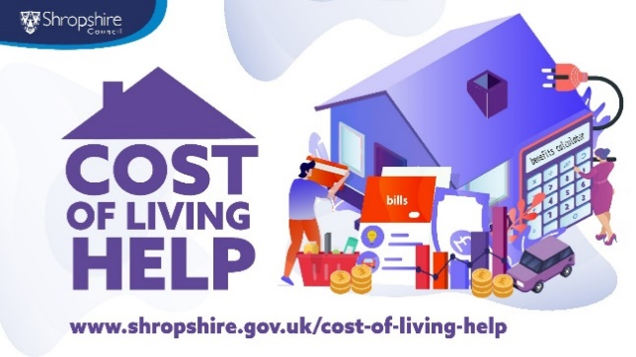
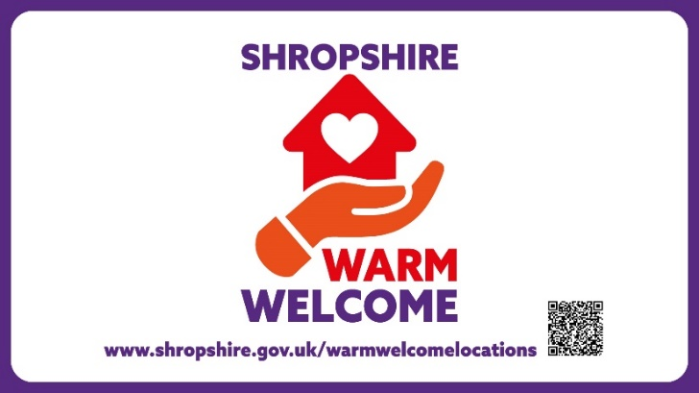

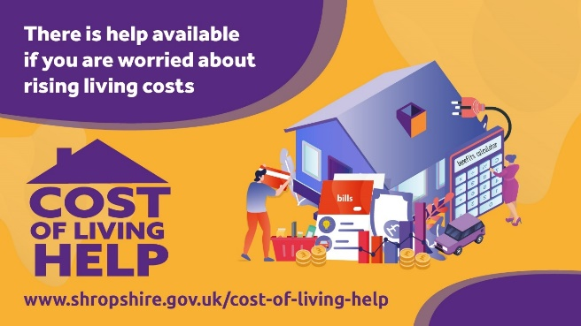
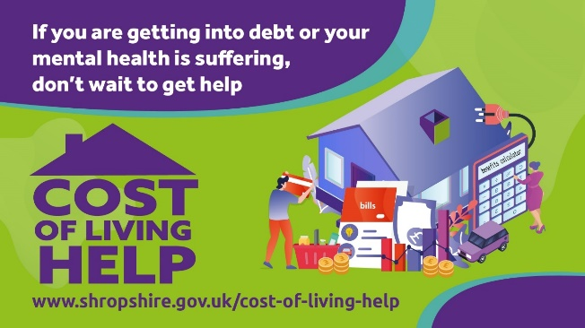

Suggested social media posts
These posts are written with Facebook and Twitter in mind but can also be used on NextDoor, Instagram and any other social media platforms.
You can also retweet and share our social media posts. Follow us at :
Twitter @shropcouncil
Facebook - Shropshire Council
Instagram - @shropshirecouncil
Next Door – Shropshire Council
LinkedIn – Shropshire Council

Facebook
If you are worried about heating your home and staying warm this winter - you are not alone 💜
More than 40 council buildings and community spaces will be offering a Warm Welcome to Shropshire residents during the colder months.
Every location offers a warm, free, safe and inclusive place for residents.
Find your nearest venue here: Warm Welcome locations | Shropshire Council

❄️It may be getting colder but Shropshire is offering a Warm Welcome to residents ❄️
Community spaces and council buildings are opening their doors this autumn and winter in response to the cost of living crisis.
Meet with friends, socialise, get advice and most importantly - keep warm!
📍Find your nearest Warm Space, opening times and what is on offer here: Warm Welcome locations | Shropshire Council
🤔 What is Shropshire's Warm Welcome?
You may have seen the Warm Welcome logo popping up in libraries and community buildings across Shropshire.
These are places you can enter free of charge this autumn and winter to keep warm if you are worried about rising energy costs.
Some locations even offer workshops, refreshments, WiFi and charging facilities.
Find your nearest Warm Welcome here: Warm Welcome locations | Shropshire Council

Twitter
You are not alone if you are worried about rising energy bills 💜
More than 80 locations in Shropshire are offering a Warm Welcome this autumn and winter.
Simply turn up and keep warm!
Find your nearest venue: Warm Welcome locations | Shropshire Council

📍 Find your nearest Warm Welcome!
In response the cost of living crisis, more than 80 venues in Shropshire have opened their doors to residents.
Every venue offers a free, safe and inclusive place for people to stay warm during the colder months.
ℹ️ Warm Welcome locations | Shropshire Council

