Three Parishes Neighbourhood Development Plan

Strategic Environmental Assessment Screening Statement

March 2023

Strategic Environmental Assessment Screening Statement for the Three Parishes Neighbourhood Development Plan (TPNDP)
Screening Statement under regulation 9 of the SEA Regulations 2004 on the determination of the need for Strategic Environmental Assessment (SEA) for the Three Parishes Neighbourhood Development Plan.
Introduction
The Government has confirmed that sustainability appraisals are only required for development plan documents and do not apply in the case of neighbourhood plans although the qualifying body must demonstrate how its neighbourhood plan will contribute to achieving sustainable development. However, neighbourhood plans must not breach and must be otherwise compatible with EU and Human Rights obligations. Neighbourhood plans therefore need to be considered against, for example, the Habitats and Strategic Assessment Directives and associated regulations. Whilst it is not the case that every neighbourhood plan will need an environmental assessment of the type normally associated with the process of preparing Local Plans, they may, subject to their scope and the issues they are seeking to address, be required to produce an environmental assessment if the plan is determined as likely to have significant environmental effects.
Strategic Environmental Assessments (SEA) are required by EU Directive 2001/42/EC, to assess the effects of certain plans and programmes on the environment. This Directive was implemented in the United Kingdom in July 2004 with the adoption of the Environmental Assessment of Plans and Programmes Regulations 2004 (the Regulations). The requirement for SEA is assessed under Regulation 9 (1). The SEA focuses on impacts on the natural environment with some limited consideration of human population needs and material assets. The Strategic Environmental Assessment (SEA) itself should, among other things, consider options, quantify potential impacts and offer advice on alternatives, or mitigating measures, where impacts are likely.
Regulation 8 of the SEA Regulations prevents the adoption or submission of a plan for which an environmental assessment is required before the SEA is completed and prohibits the adoption or submission of a plan before the responsible authority has determined whether the plan is likely to have significant effects on the environment.
It is not possible to rule out the need for an SEA without first carrying out a screening process to establish whether or not the TPNDP is likely to have significant environmental effects (Article 3(1)). Under Article 3(4) of the Directive, and Regulation 5 of the Regulations, the responsible authority must determine which plans, other than those for which an SEA is automatically required, are likely to have significant environmental effects. The “responsible authority” as defined by Regulation 2, is the authority on whose behalf a plan is prepared.
Both the Directive (in Annex II), and the Regulations (in Schedule 1), set out specific criteria for determining the likely significance of the environmental effects of a plan. The process for determining whether or not an SEA is required is called screening. These criteria include specific considerations regarding the characteristics of the plan, the effects of the plan, and the area likely to be effected by the plan.
A determination cannot be made until the three statutory consultation bodies have been consulted: the Environment Agency; Natural England; and Historic England.
Within 28 days of making its determination, the Council must publish a statement setting out its decision. If it determines that an SEA is not required, the statement must include reasons for this.
Neighbourhood Plans
Neighbourhood Planning is a community right introduced by the Localism Act 2011. Take up of the new right will be voluntary and at the discretion of neighbourhoods and communities.
The Government published a revised version of the National Planning Policy Framework in 2019, replacing almost all existing planning guidance. This was updated again in July 2021. This is what it says on neighbourhood planning:
29. Neighbourhood planning gives communities the power to develop a shared vision for their area. Neighbourhood plans can shape, direct and help to deliver sustainable development, by influencing local planning decisions as part of the statutory development plan. Neighbourhood plans should not promote less development than set out in the strategic policies for the area, or undermine those strategic policies18.
30. Once a neighbourhood plan has been brought into force, the policies it contains take precedence over existing non-strategic policies in a local plan covering the neighbourhood area, where they are in conflict; unless they are superseded by strategic or non-strategic policies that are adopted subsequently.
The Neighbourhood Planning Regulations (SI 637) came into force on 6 April 2012 and have since been amended most recently through the Neighbourhood Planning (Referendums) (Amendment) Regulations 2016 which became effective on 1st October 2016 (SI 934). This sets out the procedures for designating a Neighbourhood Plan area and getting the Plan adopted through the planning system.
Three Parishes Neighbourhood Development Plan
The TPNDP must conform to higher level policy. This means that it must conform to national and local policy including Shropshire Council’s strategic planning policy, which is contained in the Shropshire Core Strategy and the Site Allocations & Management of Development, which makes up the Development Plan.
However, the current development plan is out now out of date and therefore the existing documents are under review. Shropshire have now reached the examination stage of the Local Plan Review, an appropriate and sensible approach from this point is to proceed with the Neighbourhood Plan on the basis of the emerging strategy and policies, working closely with Shropshire Council during the preparation of the Neighbourhood Development Plan and supporting documents.
The Three Parishes of Adderley, Norton-In-Hales and Morton Say submitted its application to Shropshire Council for designation of its Neighbourhood Area in 2018. Between September and October Shropshire Council consulted on the proposed area. In advertising this information comments were invited through the ‘Get Involved’ section of the Shropshire Council website and e-mails circulated to all statutory consultees, as well as to adjoining Parish and Town Council areas. Shropshire Council received three responses to this consultation, none of which objected to the principle of the proposed Neighbourhood Area.
In response, at Cabinet it was agreed that the Three Parishes Plan Area was an appropriate basis for the development of a Neighbourhood Development Plan and notified them accordingly. A formal notice confirmed that the Neighbourhood Plan area was acceptable and was published on 12th December 2018.
Three Parishes Designated Neighbourhood Area
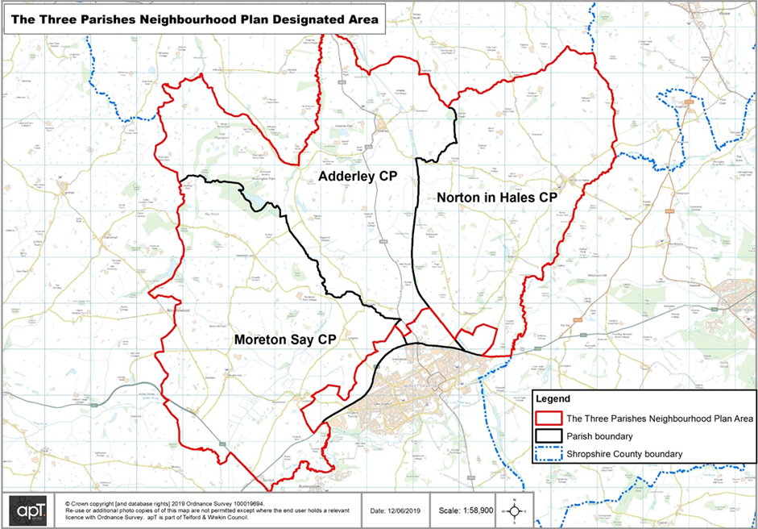
The Three Parishes Neighbourhood Plan is a community led plan that derives from the vision and objectives of people who live within the Neighbourhood Area. From the outset the Three Parishes were determined that residents be kept informed and have an opportunity to inform the content of the Plan. Communication and consultation in a variety of forms have played a major part in developing the Three Parishes Neighbourhood Plan.
The Three Parishes Neighbourhood Development Plan is based around a number of objectives that cover the following themes, these are as follows:
- Provision of Adequate Housing
- Employment Opportunities
- Natural Environment
- Transport and Movement
- Built Environment and Heritage
- Community Facilities
These themes and the related issues have informed the preparation of 14 planning objectives that in turn led to the development of draft planning policies. It is possible that these objectives and policies may be refined as the draft plan is considered at the formal consultation stages.

Three Parishes Neighbourhood Development Plan Vision Statement and Objectives
Vision
The Three Parishes wish to retain their originality and beauty for the benefit of present and future generations. Residents value their community spirit, the rural setting and ready access to the countryside. They appreciate the need to retain these aspects, whilst noting the requirement to accommodate some new development. The community sees itself as friendly and welcoming to all new residents, whilst also looking to retain the area’s values and history.
The Neighbourhood Plan must also include the wider community beyond the ‘village boundary’ that includes scattered housing, small businesses and farms. These form an integral part of the Neighbourhood Plan and need to be included in its formulation, whilst balancing the demands on the natural and historic environment.
Therefore, the Neighbourhood Plan is intended to work for the benefit and wellbeing of all the residents of the Three Parishes and retain those aspects which make and sustain a community. These include churches, local schools, village halls, green spaces, recreation facilities and community assets such as pubs and clubs, farms and small businesses. The villages should be a place to feel safe with suitable infrastructure for both pedestrians and vehicles.
The vision sees new and young families as the future and as such the Neighbourhood Plan should seek to accommodate their needs within the overall values of the community. The community must also accommodate the needs of older residents. These should include good services and communications, both physical and technological. The Neighbourhood Plan should create an environment that makes all this possible.
Objectives
Provision of Adequate Housing
- To allow future infill development in the Three Parishes which respects the variety of building styles and materials used in the area.
- Limited infill in each settlement which respects the rural outlook, maintaining gaps between settlements.
- To support the provision of an appropriate number and range of house types and tenures on appropriate sites meeting the needs of people living in the Three Parishes.
Employment Opportunities
- Encourage suitable employment opportunities through conversion of existing buildings or small well-designed buildings in appropriate locations.
Natural Environment
- To retain its largely rural character whilst having enhanced range of services and facilities offered to all age groups.
- To protect and enhance green areas, natural habitat, wildlife and biodiversity in and around the parishes and to encourage appropriate management.
- Reduce our carbon emissions, making sure development mitigates for and enables adaption to the effects of climate change.
Transport and Movement
- To work and improve public transport opportunities minimising the use of cars in and around the parishes, and reduce the associated problems of noise, pollution and parking.
- To provide a safe, accessible and well-maintained network of roads, cycle routes, footpaths, rights of way and pavements, whilst retaining rural character to support more sustainable modes of transport and offering healthier lifestyle options.
Built Environment and Heritage
- To respect the Norton in Hales conservation area and support sympathetic design to protect and enhance the conservation area to the benefit of the entire community.
- To protect the character and setting of the Three Parishes historic buildings, ensuring new development is in keeping with other buildings and their surroundings.
Community Facilities
- To protect existing facilities and services considered important for a vibrant community, supporting development of new ones which will benefit the community.
- Increase opportunities to access community facilities and to enhance the range of activities and facilities available for all.
- To encourage suitable employment opportunities and communications connectivity (broadband and mobile phone).
Monitoring and Review
The Three Parishes will monitor the delivery of its policies and work to ensure that benefits to the communities within the Parish are achieved.
Assessment of Requirement for Strategic Environmental Assessment
The Government has set down planning guidance following publication of the National Planning Practice Guidance (NPPG). The guidance advises that ‘To decide whether a draft neighbourhood plan might have significant environmental effects, it must be assessed (screened) at an early stage of the plan’s preparation according to the requirements set out in regulation 9 of the Environmental Assessment of Plans and Programmes Regulations 2004. These include a requirement to consult the environmental assessment consultation bodies. Where it is determined that the plan is unlikely to have significant environmental effects (and, accordingly, does not require an environmental assessment), a statement of reasons for the determination should be prepared.’
In principle, neighbourhood plans should not be subject to the SEA Directive or require sustainability appraisal because they do not normally introduce new policies or proposals or modify planning documents which have already been subject to sustainability appraisal. However, they might occasionally be found likely to give rise to significant effects that have not been previously assessed. In screening a plan, Article 3 (6) of the SEA Directive requires that the relevant bodies concerned with environmental matters, as defined by individual Member states, shall be consulted as part of the screening process. In the case of the UK, the statutory environmental consultees are: Natural England; the Environment Agency; and Historic England.
It is considered that the screening methodology should address the issues identified in the table below.

Screening Stage | Purpose
Assessing the TPNDP against Annex II Criteria | To establish whether or not the TPNDP is likely to have a significant effect on the Annex II criteria. This will take account of the role of the TPNDP in relation to existing policy context
Conclusion on whether the screening exercise identifies a need for SEA | To set out conclusions from the screening exercise
Recommendations for how the TPNDP should proceed in relation to SEA requirements | To set out the broad approach needed to carry out an SEA on the TPNDP or, where the screening report suggests no SEA is required, to determine the parameters within which the TPNDP will need to operate to avoid triggering a need for SEA.

Assessing the TPNDP against Annex II Criteria
Annex II of the SEA Directive sets out the criteria for determining if there are likely to be significant effects resulting from the implementation of a plan.
Criteria for determining the likely significance of effects (Annex II SEA Directive) | Likely to have significant environmental effects | Summary of significant effects
1a) The degree to which the plan or programme sets a framework for projects and other activities, either with regard to the location, nature, size and operating conditions or by allocating resources. | No | The TPNDP proposes a framework for development proposals focussing on limiting the amount of housing, conserving and enhancing where possible the landscape quality and character, support small economic development, protecting and improving community amenities whilst also promoting sustainable movement and travel.  Shropshire Council’s Local Plan Review policy SP1 supports development that will contribute to meeting local needs and that make its settlements more sustainable.  Policy S11.3 considers community clusters that fall within the Market Drayton Place Plan Area receiving development to support that function. Residential development will contribute towards achieving the housing guideline for the rural area of Shropshire. Allocations from the adopted SAMDev will be delivered alongside small scale windfall residential development.
1(b) The degree to which the plan or programme influences other plans or programmes including those in a hierarchy. | No | The TPNDP responds to other plans and programmes such as the Shropshire Development Plan and the NPPF. The TPNDP has been specifically guided by and is aligned with the aims and objectives of the Shropshire Local Plan Review and is likely to have a positive impact on these plans through its policies to deliver sustainable development and protect and enhance the local character and environment.
1(c) The relevance of the plan or programme for the integration of environmental considerations in particular with a view to promoting sustainable development. | No | The TPNDP recognises the objective of achieving sustainable development in the local area.  The TPNDP contains policies that seek to protect and retain local open spaces, protect and enhance biodiversity, reduce carbon emissions, provide small scale housing where appropriate and help to promote and support existing services and facilities.  The TPNDP seeks to promote opportunities for alternative sustainable means of travel as well providing opportunities to support small-scale employment and farm diversification.  The TPNDP acknowledges the need for small infill development, subject to clear local evidence of housing need.  Proposal set out within the TPNDP are designed to have a positive impact on local environmental assets and places valued by local people in the TPNDP area. They will primarily focus on the protection and enhancement of open spaces, biodiversity and historic buildings, as well as limiting the impact of pollution and supporting the transition to a zero-carbon economy by measures to meet a high level of sustainability and energy efficiency.
1(d) Environmental problems relevant to the plan | No | There are no major allocations identified for housing and employment within the TPNDP area.  Policy SP6 of the Shropshire Local Plan Review promotes safe and well ‘lit high quality walk and cycling routes. Policy SP3 and DP28 also prioritises use of active travel between new developments and from new developments to existing neighbourhoods and community facilities.  Environmental issues may be triggered through the development of suitable infill housing sites. However, these sites will need to be in conformity with both national and local policy and, in particular, both the Local Plan and TPNDP which seek to prevent environmental harm and promote and improve environmental quality.  There are no Air Quality Management Areas within the TPNDP area.
1(e) The relevance of the plan or programme for the implementation of Community legislation on the environment (e.g. plans and programmes linked to waste management or water protection) | No | The TPNDP policies do not propose any changes that are likely to have a severe impact on the environment i.e. tree preservation orders or existing public rights of way. The Local Plan chapter on the Natural and Historic Environment contains positive enabling policies. The TPNDP has adopted a similar approach that is intended to have a positive effect.
2(a) The probability, duration, frequency and reversibility of the effects | No | Due to the limited scale of any new development, it is unlikely that the TPNDP would result in any irreversible damaging environmental impacts. All new development should be sustainable and be in accordance with existing planning policy.
2(b) The cumulative nature of the effects | No | It is not possible to fully assess the cumulative effects of future development until planning applications have been submitted and assessed. However, it is anticipated that forthcoming issues could include the effect on school capacity, highway safety and the loss and movement of jobs. It may be possible to address some or all of these cumulative issues through mitigation measures, financial contributions, and in the detailed part of the planning application process. Further to this it is thought the policies within the TPNDP will generate positive effects.  Application of the policies contained in the TPNDP attempt to prevent detrimental cumulative effects by assuring that new development will address environmental, social and economic issues created by each development.
2(c) The transboundary nature of the effects | No | The small scale infill housing and small scale employment proposals of the TPNDP are unlikely to generate any significant cross-boundary effects.  Improvements to more sustainable transport modes and linkages, including cycling, walking should help to minimise any transboundary effects.
2(d) The risks to human health or the environment (e.g. due to accidents) | No | It is unlikely that there will be any obvious risks to human health arising from the policies within the TPNDP.  Health and Safety standards on developments arising within the plan area will be controlled/ governed by relevant statutory guidelines and codes. Any risks arising from the policies and proposals in the TPNDP will be managed in accordance with the relevant statutory frameworks; however no details have been submitted or are shown within the plan.
2(e) The magnitude and spatial extent of the effects (geographical area and size of the population likely to be affected) | No | The TPNDP covers the parishes of Adderley, Norton-In-Hales and Moreton Say which covers an area of approximately 5, 966 hectares. The TPNDP is likely to affect a residential population of approximately 1477 people over the life of the Plan across the three parishes located in the rural area. The population of the three parishes is likely to grow further.
2(f) The value and vulnerability of the area likely to be affected due to:  - special natural characteristics or cultural heritage  - exceeded environmental quality standards  - intensive land-use | No | The TPNDP is unlikely to adversely affect the value and vulnerability of the area in relation to its natural or cultural heritage. If anything it will provide greater support to enhance the setting of heritage assets and of green spaces.  Where possible, policies will encourage new opportunities for recreation, access and leisure.  The TPNDP policies will aim to preserve and enhance all known sites of ecological or environmental importance.  The policies contained in the TPNDP provide opportunities for development if they are planned and designed to protect and enhance local wildlife species and habitats.  The plan also seeks to support the transition to a zero carbon economy including effective measures to minimise pollution and to meet high levels of sustainability and energy efficiency.  These are in line with policies in the Local Plan dealing with the Natural and Historic Environment and Climate Change.
2 (g) The effects on areas or landscapes which have a recognised national, community or international protection status. | No | It is considered that the TPNDP is unlikely to have an adverse impact on its existing landscapes.  Whilst there are areas of grade 2, 3 and 4 agricultural land within the parishes the plan does not propose any new development on the best and most versatile land.  A statement on Habitats Regulations Assessment has been prepared identifying whether a plan is likely to have a significant effect on a European site, either alone or in combination with other plans or projects.  The plan proposes to provide opportunities for development if they are planned and designed to protect and enhance local wildlife species and habitats.

Conclusion of the SEA Screening Process for the Three Parishes Neighbourhood Development Plan
The policies within the Three Parishes Neighbourhood Development Plan have been screened under the Strategic Environment Assessment process.
The conclusion of the SEA Screening Process is that none of the proposed policies within the draft Three Parishes Neighbourhood Development Plan has the potential to have a significant effect on the natural environment.
The draft Three Parishes Neighbourhood Development Plan can be ‘screened out’ of the Strategic Environment Assessment process and an ‘Appropriate Assessment’ is not required.

